M Pharmacy Notes
Advances in
Drug Delivery
System
(MPT102T)
M. Pharmacy – Pharmaceutical Technology – Semester I

Connect With Us
Website - www.carewellpharmacy.in
Telegram - Carewell Pharmacy

Syllabus & Course Overview
Scope
This course is designed to impart knowledge on the area of advances in novel drug delivery systems. It builds on the fundamentals of physical pharmacy, biopharmaceutics and pharmaceutics and introduces the modern approaches by which the rate, time and site of drug release can be modulated to obtain a superior therapeutic outcome. The student is trained to appreciate why a conventional dosage form is often sub-optimal and how rational design of the delivery system can improve efficacy, safety and patient compliance.
Objectives
Upon completion of this course it is expected that the students will be able to understand :
➢ Recent innovations in conventional dosage forms – including site-specific delivery and time-release (temporal) modulation.
➢ Preparation, evaluation and application of new drug delivery systems.
➢ The criteria for selection of drugs and polymers for the development of a delivery system.
Course Contents (Theory – 60 Hrs)
Unit | Topic | Hrs
1 | Sustained Release (SR) & Controlled Release (CR) Formulations – basic concepts, terminology, advantages/disadvantages, drug candidate selection, dosage calculations, physicochemical & biological factors and approaches, mechanism of release, classification, design, fabrication, evaluation & applications of oral CDDS. | 10
2 | Oral Sustained Release DDS – physicochemical & biological factors; dissolution-controlled, diffusion-controlled, bio-erodible, osmotically controlled, ion-exchange and mucoadhesive drug delivery systems. | 5
3 | Microencapsulation – definition, objectives, release & stability kinetics, coating materials, methods of preparation, evaluation & applications. | 5
4 | Implants and Inserts – host–implant and implant–host reactions; subcutaneous, intramuscular, intra-ocular, intra-vaginal and intra-uterine systems. | 15
5 | Transdermal Drug Delivery Systems – skin permeation fundamentals, development approaches, kinetic evaluation, formulation design & optimization; sonophoresis, iontophoresis and latest skin-delivery developments. | 10
6 | Personalized Medicine – introduction, definition, pharmacogenetics, categories of patients; customized DDS, bioelectronic medicines, 3D printing of pharmaceuticals and telepharmacy. | 15

Recommended Books
➢ Encyclopedia of Pharmaceutical Technology – J. Swarbrick & J. C. Boylan.
➢ Theory and Practice of Industrial Pharmacy – L. Lachman, H. Lieberman.
➢ Modern Pharmaceutics – G. S. Banker & C. T. Rhodes.
➢ Controlled Drug Delivery : Fundamentals & Applications – J. R. Robinson & V. H. Lee.
➢ Novel Drug Delivery Systems – Y. W. Chien.
➢ Targeted & Controlled Drug Delivery – S. P. Vyas & R. K. Khar.
➢ Advances in Controlled and Novel Drug Delivery – (Ed.) N. K. Jain.
★ How to use these notes
• Each unit contains detailed theory, labelled diagrams, worked examples, summary tables and highlighted boxes.
• ★ boxes highlight high-yield points frequently asked in university theory papers and viva.
• A list of important questions, a glossary and a consolidated Quick-Revision section are given at the end.
• As the paper is theoretical, focus on definitions, classifications, mechanisms, labelled diagrams, merits/demerits and applications.

Introduction to Novel Drug Delivery Systems
I.1 The Need for Novel Drug Delivery
A drug is of little value unless it is delivered to its site of action at the right concentration, for the right duration, with minimal exposure of other tissues. Conventional dosage forms release the whole dose promptly and rely on the body to distribute and eliminate it; this produces fluctuating plasma levels, frequent dosing, systemic exposure of non-target tissues and, for many modern drugs (poorly soluble, unstable or macromolecular), inadequate or unreliable delivery. Novel drug delivery systems (NDDS) were developed to overcome these limitations by controlling the rate (temporal control) and/or the place (spatial control) of drug release.
I.2 Temporal and Spatial Control
➢ Temporal (rate) control : delivering the drug at a defined rate over a defined time – sustained, controlled, delayed, pulsatile and chronotherapeutic systems.
➢ Spatial (site) control : delivering the drug to a specific organ, tissue, cell or receptor – targeted and site-specific systems.
➢ Combined control : the most advanced systems control both rate and place simultaneously.
I.3 Ideal Characteristics of a Drug Delivery System
1. Deliver the drug at a controlled, predictable and reproducible rate.
2. Maintain the therapeutic concentration for the desired duration with minimal fluctuation.
3. Direct the drug to the target site and spare non-target tissues (where required).
4. Be safe, biocompatible and free of toxic degradation products.
5. Protect the drug from premature degradation.
6. Improve patient compliance and convenience.
7. Be simple to manufacture, stable on storage and economical.
I.4 Evolution / Generations of Drug Delivery
The development of drug delivery is often described in generations :
➢ First generation (1950s–1980s) : basic sustained- and controlled-release oral and transdermal systems; establishing the physicochemical principles of release.
➢ Second generation (1980s–2010) : smart / self-regulated systems, targeting, nanocarriers and delivery of peptides / proteins – many scientific successes but fewer clinical products because of biological barriers.
➢ Third generation (2010–present) : modulation of the biological environment, overcoming physiological barriers, personalized and 'smart' responsive delivery, and manufacturing advances such as 3D printing.
I.5 Classification of Novel Delivery Systems
Basis | Types
Rate of release | Immediate, sustained, controlled, delayed, pulsatile
Route / site | Oral, transdermal, ocular, nasal, pulmonary, implantable, vaginal, uterine
Mechanism | Diffusion, dissolution, osmotic, ion-exchange, erosion, swelling
Carrier | Matrix / reservoir devices, microspheres, implants, patches, vesicles

I.6 Scope of this Course
This course focuses on the systems specified in the syllabus : sustained and controlled release formulations and their oral mechanisms; microencapsulation; implants and inserts; transdermal systems; and the emerging field of personalized medicine. Throughout, emphasis is placed on the criteria for selecting suitable drugs and polymers, the mechanism of release, and the preparation, evaluation and application of each system.

Unit I – Sustained & Controlled Release Formulations
1.1 Introduction & Basic Concepts
The conventional (immediate-release) dosage form is designed to release the whole of its drug content promptly after administration so as to produce a rapid and complete systemic absorption. Although simple and inexpensive, such systems suffer from a characteristic 'peak-and-valley' plasma profile when the drug is given repeatedly. The plasma concentration rises above the minimum effective concentration (MEC), often overshooting the minimum toxic concentration (MTC), and then falls below the MEC before the next dose, so that the patient oscillates between periods of over-medication (toxicity) and under-medication (no effect). Frequent dosing also lowers patient compliance.
A rate-controlled delivery system is designed to overcome these limitations by delivering the drug at a pre-determined rate, for a pre-determined period, and (in advanced systems) at a pre-determined site, so that the plasma concentration is maintained within the therapeutic window for a prolonged time from a single administration.
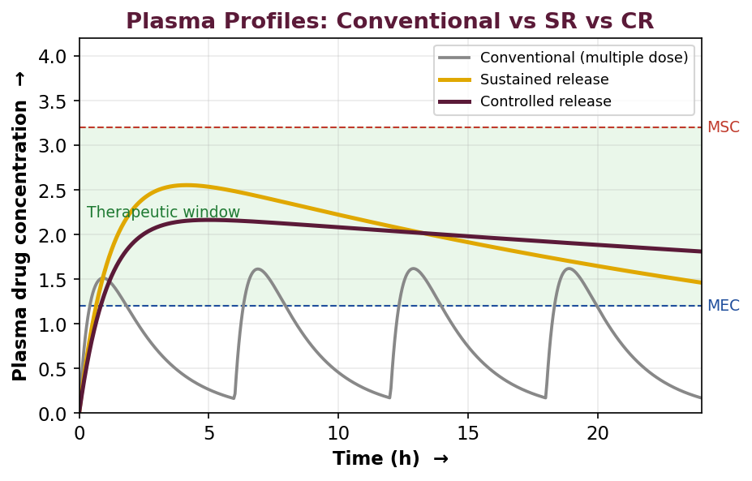
Fig. 1 : Plasma drug concentration vs time for conventional, sustained and controlled release systems (MEC = minimum effective conc., MSC = maximum safe conc.)
Therapeutic Window
The therapeutic window (therapeutic range) is the range of plasma drug concentration that lies between the minimum effective concentration (MEC) and the maximum safe / toxic concentration (MSC / MTC). An ideal delivery system keeps the plasma level within this band for the entire duration of therapy. The narrower the window, the greater the need for rate control.
Rationale for Rate-Controlled Delivery
➢ To maintain a constant, therapeutically effective plasma level with minimum fluctuation.
➢ To reduce the frequency of administration (e.g., once or twice daily instead of every few hours).
➢ To reduce the total dose and dose-related side effects.
➢ To improve patient compliance and convenience.
➢ To deliver the drug to a specific site when required (spatial control).
➢ To make the therapy more economical over the course of treatment.
1.2 Terminology of Modified-Release Systems
The term 'modified-release' is an umbrella term covering all dosage forms whose drug-release characteristics of time-course and/or location are chosen to accomplish therapeutic or convenience objectives not offered by conventional forms. The important sub-categories are defined below.
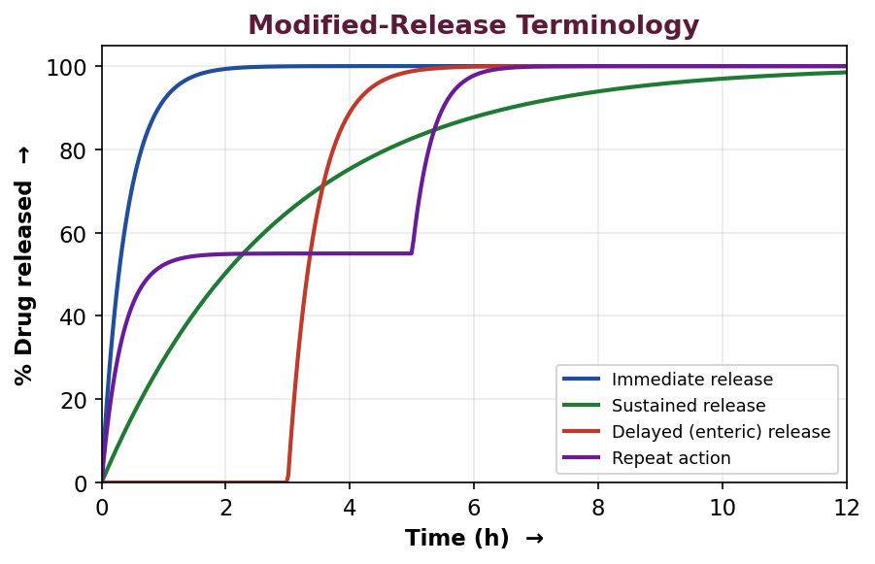
Fig. 2 : Release profiles illustrating immediate, sustained, delayed and repeat-action systems
Sustained-Release System
A system that provides an initial dose sufficient to produce the therapeutic response promptly, followed by a gradual (slower) release of drug at a rate that will maintain the therapeutic level over an extended period. The release rate is slowed but is not necessarily constant – i.e., sustained release prolongs the duration of action but does not strictly control the plasma level. (Synonyms : sustained-action, prolonged-action, extended-release, retard.)
Controlled-Release System
A system that releases the drug at a pre-determined, usually constant (zero-order) rate and, ideally, maintains a constant plasma or tissue concentration for a defined period. Controlled release implies a higher degree of control over the temporal and sometimes spatial delivery than sustained release; it seeks to reduce the plasma-level fluctuation to near zero.
★ SR vs CR – the key distinction
• Sustained release – only prolongs the duration of action; release rate declines with time (usually first-order / Higuchi); some fluctuation persists.
• Controlled release – maintains a constant drug level by releasing at a constant (zero-order) rate; predictable and reproducible; little or no fluctuation.
• Thus every CR system is sustained, but not every SR system is truly controlled.

Other Terms
Delayed-release system : releases the drug at a time other than promptly after administration, e.g., enteric-coated tablets that release drug only after they leave the stomach. The total amount is released but at a later time; the rate is not necessarily slowed.
Repeat-action system : releases one dose immediately and a second (or subsequent) equal dose after a lag period, mimicking repeated administration; typically a coated inner core within an immediate-release outer layer.
Site-specific / targeted system : delivers the drug to a particular organ, tissue or cell (spatial placement of control) – e.g., colon-targeted, hepatic or tumour-targeted systems.
Receptor targeting : delivery directed to a particular receptor for a drug within an organ or tissue – the ultimate refinement of site-specific delivery.
Extended-release : an FDA/USP term encompassing both sustained- and controlled-release products that allow at least a two-fold reduction in dosing frequency compared with the conventional form.
Term | Temporal control | Spatial (site) control | Example
Immediate release | None (prompt) | None | Conventional tablet
Sustained release | Prolonged, rate declines | None | Matrix retard tablet
Controlled release | Constant (zero-order) | Sometimes | Osmotic pump (OROS)
Delayed release | Time-shifted | GI region | Enteric-coated tablet
Repeat action | Pulsatile (2 doses) | None | Two-layer coated tablet
Site specific | Optional | Organ / tissue | Colon-targeted capsule

1.3 Advantages & Disadvantages of SR / CR Systems
Advantages
1. Improved patient compliance due to reduced frequency of dosing.
2. Reduced plasma-level fluctuation – a more uniform effect and fewer concentration-dependent adverse effects.
3. Reduction in total dose of drug used over the course of therapy in many cases.
4. Reduced night-time dosing and uninterrupted sleep for the patient.
5. Reduction of drug accumulation with chronic therapy.
6. Improved efficiency of treatment – better control of the condition with a smoother response.
7. Economy – although unit cost is higher, the overall cost of therapy may be lower.
Disadvantages
1. Dose dumping – accidental, rapid release of the entire dose can cause toxicity if the system fails.
2. Poor in-vivo / in-vitro correlation in some cases.
3. Reduced ability to adjust the dose or to promptly terminate therapy (e.g., in adverse reactions the dose cannot be quickly withdrawn).
4. Higher cost of manufacture and sophisticated technology required.
5. First-pass metabolism may reduce bioavailability of some drugs delivered slowly.
6. Increased potential for variability due to GI transit, food and disease.
7. Not suitable for all drugs – the drug and dose must satisfy specific criteria (see below).
1.4 Drug Candidate Selection for SR / CR Dosage Forms
Not every drug is a suitable candidate for a rate-controlled system. The selection is governed by the physicochemical, pharmacokinetic and pharmacodynamic properties of the drug. The following are the desirable and the disqualifying characteristics.
Physicochemical Factors influencing the design
➢ Aqueous solubility & pH-dependent solubility : very poorly soluble drugs (< 0.01 mg/mL) are difficult to sustain because dissolution itself is rate-limiting; highly soluble drugs are hard to retard. An intermediate solubility is ideal.
➢ Partition coefficient (log P) : governs the ability to cross biological membranes; extremely high or low log P values are unfavourable. A balanced lipophilicity is required for both membrane transport and release control.
➢ Drug stability : drugs unstable in the environment of a particular GI segment are poor candidates for that region; e.g., drugs degraded in the small intestine benefit from rapid-release forms.
➢ Molecular size & diffusivity : large molecules (> 500 Da onwards) diffuse slowly through polymeric membranes / matrices; the diffusion coefficient falls with increasing molecular size.
➢ Protein binding : highly protein-bound drugs already have a prolonged biological half-life and may not need sustaining.
➢ pKa & degree of ionisation : since only the unionised form permeates, the pKa relative to the pH of the absorption site is important.
Biological (Pharmacokinetic / Pharmacodynamic) Factors
➢ Biological half-life (t½) : the ideal candidate has t½ of about 2–8 h. Drugs with very short t½ (< 1 h) need an impractically large dose; drugs with long t½ (> 8 h, e.g., digoxin, warfarin) are inherently sustained and need no formulation aid.
➢ Absorption rate & window : the drug should be well and uniformly absorbed throughout the GI tract. Drugs with a narrow 'absorption window' (absorbed only from the upper GI, e.g., riboflavin, iron) are poor candidates unless gastro-retentive.
➢ Rate of metabolism : drugs extensively metabolised or that induce/inhibit enzymes may show non-linear kinetics and are difficult to formulate.
➢ Dosing size (dose) : a single dose > 0.5–1.0 g leads to an unacceptably large SR unit.
➢ Therapeutic index : drugs with a narrow therapeutic index require precise rate control; dose dumping would be dangerous.
➢ Margin of safety & MEC/MTC : a well-defined and reasonably wide therapeutic window is desirable.
★ Ideal characteristics of a drug for SR/CR
• Molecular weight < 500 Da; moderate aqueous solubility (not < 0.1 mg/mL).
• Biological half-life between 2 and 8 h.
• Uniform absorption from the whole GI tract; good stability in GI fluids.
• Dose < 0.5 g; wide therapeutic index; first-order (linear) pharmacokinetics.
• Neither very high nor very low apparent partition coefficient.

Drugs unsuitable for SR / CR
➢ Drugs with very short or very long half-life.
➢ Drugs requiring large doses (> 1 g).
➢ Drugs with narrow absorption window / poor absorption in the lower GI.
➢ Drugs whose action is intended to be prompt and short (e.g., analgesics for acute pain in some cases).
➢ Drugs with low therapeutic index (unless very precise control is guaranteed).
1.5 Dosage Calculations for SR / CR Systems
A sustained-release product usually contains two portions of drug : an immediate-release (loading / initial) dose D₀ that promptly raises the plasma level to the therapeutic value, and a maintenance (sustaining) dose Dₘ that is released slowly to compensate for elimination. The total dose is the sum of the two.
Maintenance dose and release rate
For a system that is to deliver drug at a zero-order rate equal to the rate of elimination, the desired release rate (Kᵣ₀) is :
Kᵣ₀ = Rate of elimination = Cₚ × CL = Cₚ × kₑ × Vd
where Cₚ is the desired steady-state plasma concentration, CL is the total body clearance, kₑ is the first-order elimination rate constant and Vd is the volume of distribution.
The total maintenance dose to sustain the level for a time Tᵈ is :
Dₘ = Kᵣ₀ × Tᵈ = Cₚ × kₑ × Vd × Tᵈ
Loading (initial) dose
The loading dose that immediately establishes the therapeutic level is :
D₀ = Cₚ × Vd (for i.v.) ; D₀ = Cₚ × Vd / F (for oral, F = bioavailability)
When the maintenance system begins releasing drug immediately, a correction is applied because some maintenance drug is released during the time the loading dose is still effective :
D₀ (corrected) = D₀ – (Kᵣ₀ × Tₚ)
where Tₚ is the time to reach peak concentration from the immediate-release portion.
Total dose W = D₀ + Dₘ = D₀ + Kᵣ₀ × Tᵈ.
Worked Example
★ Numerical
• A drug has t½ = 4 h, Vd = 20 L and desired Cₚ = 10 mg/L. Design a 12-h SR dose (assume F = 1).
• Step 1 – kₑ : kₑ = 0.693 / 4 = 0.173 h⁻¹.
• Step 2 – Loading dose : D₀ = Cₚ × Vd = 10 × 20 = 200 mg.
• Step 3 – Release rate : Kᵣ₀ = Cₚ × kₑ × Vd = 10 × 0.173 × 20 = 34.6 mg/h.
• Step 4 – Maintenance dose (for 12 h) : Dₘ = 34.6 × 12 = 415 mg.
• Total dose : W = 200 + 415 = 615 mg.

1.6 Physicochemical & Biological Approaches to SR / CR
Rate control can be achieved by chemical modification of the drug molecule, by physical / formulation approaches, or by exploiting biological handling of the drug. The main strategies are summarised below.
Physicochemical Approaches
➢ Prodrugs : a bio-reversible derivative that regenerates the active drug slowly, prolonging action (e.g., depot esters).
➢ Salt / complex formation : poorly soluble salts, resonates or complexes release the drug slowly (e.g., penicillin G procaine, drug–tannate complexes).
➢ Adjustment of particle size / polymorph : larger particles or a less soluble polymorph dissolve more slowly.
➢ Coating : film or micro-encapsulation with polymers of controlled permeability.
➢ Embedding in a matrix : wax, hydrophilic or plastic matrices retard diffusion / dissolution.
➢ Osmotic control : water influx through a semipermeable membrane pumps out drug solution at a constant rate.
Biological Approaches
➢ Modifying the molecule for slower metabolism or slower renal clearance.
➢ Co-administration of an adjuvant that slows absorption or metabolism (e.g., a vasoconstrictor with a local anaesthetic; a metabolism inhibitor).
➢ Altering the route to a depot site (i.m., s.c.) to obtain slow absorption.
Mechanisms of Drug Delivery / Release from SR-CR Systems
The rate-limiting step in a SR/CR system may be diffusion, dissolution, osmosis, ion-exchange or erosion. These are treated in detail in Unit II. In brief :
➢ Diffusion-controlled : drug diffuses through a polymer membrane (reservoir) or matrix (monolithic).
➢ Dissolution-controlled : a slowly dissolving coat or matrix controls the rate at which drug becomes available.
➢ Osmotically controlled : osmotic pressure drives constant delivery.
➢ Ion-exchange controlled : drug bound to a resin is released by exchange with GI ions.
➢ Erosion / bioerosion-controlled : release accompanies gradual erosion of a biodegradable matrix.
1.7 Classification of Oral Controlled Drug Delivery Systems
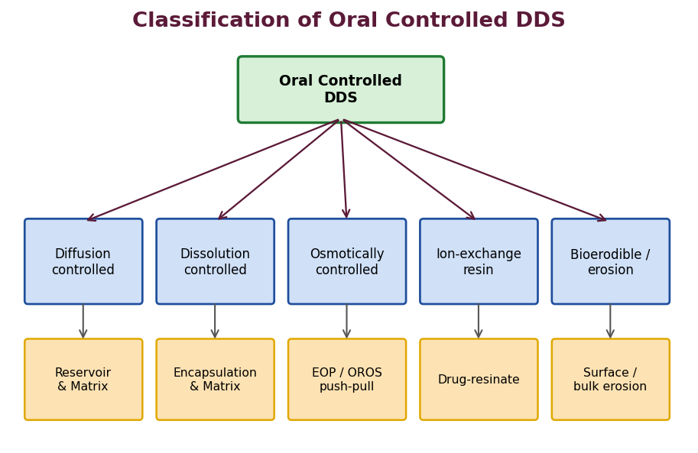
Fig. 3 : Classification of oral controlled drug delivery systems
Oral CDDS may be broadly classified according to the rate-controlling mechanism into the following groups :
1. Diffusion-controlled systems – reservoir (membrane) and matrix (monolithic) devices.
2. Dissolution-controlled systems – encapsulation (coated) and matrix (embedded) devices.
3. Diffusion + dissolution (dual) systems – combining both mechanisms.
4. Osmotically controlled systems – elementary and push-pull osmotic pumps.
5. Ion-exchange resin systems.
6. Gastro-retentive & bioerodible systems.
1.8 Design, Fabrication, Evaluation & Applications of Oral CDDS
Design considerations
➢ Selection of drug candidate satisfying the criteria of section 1.4.
➢ Choice of rate-controlling mechanism and polymer / excipient.
➢ Fixing the target release rate (zero-order desirable) and duration.
➢ Deciding the loading and maintenance dose fractions.
➢ Ensuring stability, manufacturability and reproducibility of release.
Fabrication techniques
➢ Matrix tablets : drug + rate-controlling polymer (HPMC, ethylcellulose, waxes) compressed directly or after granulation.
➢ Coated multiparticulates (pellets / beads) : drug layered on non-pareils then film-coated; filled into capsules.
➢ Osmotic tablets : core compressed and coated with a semipermeable membrane, then laser-drilled.
➢ Micro-encapsulation : coacervation, spray drying, etc. (Unit III).
Evaluation of oral CDDS
➢ Physical tests : weight variation, hardness, friability, thickness.
➢ Drug content & content uniformity.
➢ In-vitro dissolution / release using USP apparatus; data fitted to kinetic models (zero-order, first-order, Higuchi, Korsmeyer–Peppas).
➢ Release-mechanism analysis via the diffusional exponent n of the Korsmeyer–Peppas model.
➢ Stability & accelerated studies as per ICH.
➢ In-vivo / bioavailability & IVIVC studies.
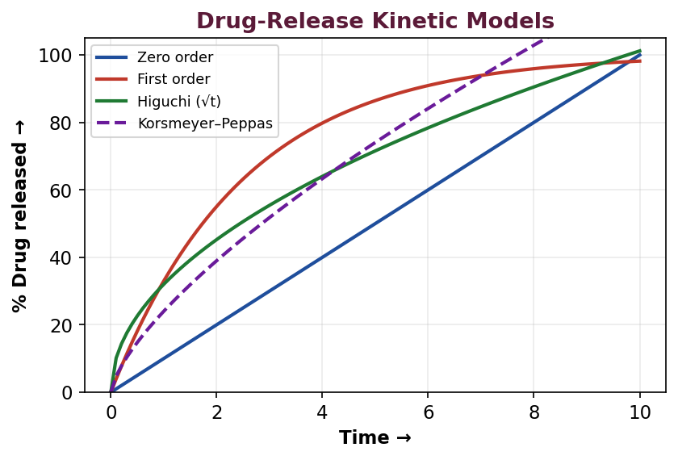
Fig. 4 : Common drug-release kinetic models used to characterise CDDS
Applications
➢ Once-daily antihypertensives (nifedipine GITS, diltiazem CD).
➢ Sustained-release analgesics and anti-inflammatory agents.
➢ Extended-release antidiabetics (metformin XR).
➢ Prolonged-release theophylline and antihistamines.
➢ Chronotherapeutic (time-controlled) delivery of cardiovascular drugs.

1.9 Pharmacokinetic Basis of Sustained Release
A rational SR design begins with the pharmacokinetics of the drug. For a drug obeying one-compartment first-order kinetics, the amount of drug in the body at steady state and the required input rate can be calculated so that the release rate matches the elimination rate. The important relationships are given below.
Rate of elimination and desired input rate
At steady state the rate of drug input equals the rate of elimination. For a zero-order input from the delivery system :
Input rate (Kᵣ₀) = Elimination rate = kₑ × Ab,ss = kₑ × Cp,ss × Vd
where Ab,ss is the amount in the body at steady state and Cp,ss the steady-state plasma concentration. Because kₑ = 0.693/t½, drugs with a short half-life require a proportionally larger maintenance dose, which is why very short-t½ drugs are impractical for SR.
The maintenance-to-loading dose ratio
The relative sizes of the loading dose (D₀) and the maintenance dose (Dₘ) depend on the half-life and the intended duration. As the intended duration of sustaining (Tᵈ) increases or the half-life decreases, the maintenance fraction grows relative to the loading dose.
★ Worked Example – short vs long half-life
• Two drugs A and B both need Cp = 5 mg/L with Vd = 15 L, sustained for 10 h.
• Drug A (t½ = 2 h) : kₑ = 0.347 h⁻¹; Kᵣ₀ = 5 × 0.347 × 15 = 26 mg/h; Dₘ = 260 mg.
• Drug B (t½ = 6 h) : kₑ = 0.116 h⁻¹; Kᵣ₀ = 5 × 0.116 × 15 = 8.7 mg/h; Dₘ = 87 mg.
• Conclusion : the short-t½ drug A needs ~3× the maintenance dose – illustrating why moderate half-lives are preferred.

1.10 Release Kinetics & Mathematical Models (in detail)
The in-vitro release data of a CDDS are fitted to mathematical models to characterise the mechanism and to compare formulations. The principal models are :
Zero-order model
Qₜ = Q₀ + k₀ t
A plot of cumulative % released versus time is linear; ideal for controlled release. Osmotic pumps and well-designed reservoir systems approach this behaviour.
First-order model
log Q = log Q₀ – (k₁ t / 2.303)
A plot of log(% remaining) versus time is linear; typical of matrix systems releasing water-soluble drugs and of many conventional formulations.
Higuchi model
Q = kₕ √t
Cumulative release is proportional to the square-root of time; describes diffusion-controlled release from a homogeneous or granular matrix. Assumptions include : initial drug concentration in the matrix is much higher than solubility; drug diffusion is one-dimensional; sink conditions are maintained; the matrix does not dissolve.
Korsmeyer–Peppas (power-law) model
Mt / M∞ = k tⁿ
Used when the mechanism is unknown or more than one type of release is involved. The release exponent n identifies the mechanism.
Exponent n (cylinder) | Release mechanism
n ≤ 0.45 | Fickian diffusion (Higuchi)
0.45 < n < 0.89 | Anomalous (non-Fickian) transport
n = 0.89 | Case-II transport (zero-order, erosion)
n > 0.89 | Super case-II transport

Hixson–Crowell model
Q₀^(1/3) – Qₜ^(1/3) = k t
Describes release from systems where the surface area and diameter change (erosion / dissolution of particles) – the 'cube-root' law.
1.11 In-Vitro / In-Vivo Correlation (IVIVC) for CDDS
IVIVC is a predictive mathematical model describing the relationship between an in-vitro property of a dosage form (usually the extent or rate of dissolution) and a relevant in-vivo response (plasma concentration or amount absorbed). A good IVIVC allows dissolution testing to serve as a surrogate for bioequivalence studies, which is particularly valuable for CDDS whose performance depends heavily on release.
Level | Correlation | Usefulness
Level A | Point-to-point (dissolution vs absorption) | Highest; can waive bioequivalence
Level B | Mean dissolution time vs mean residence time | Uses statistical moments
Level C | Single point (e.g., % at 1 h vs Cmax) | Weakest; limited use
Multiple C | Several time points vs a PK parameter | Better than single C

1.12 Gastro-retentive Drug Delivery Systems (GRDDS)
Drugs with a narrow absorption window in the upper GI tract, drugs that act locally in the stomach, or drugs unstable in the intestine benefit from being retained in the stomach. Gastro-retentive systems prolong gastric residence and thereby improve absorption and the utility of CDDS.
Approaches to gastric retention
➢ Floating (low-density) systems : density less than gastric fluid (< 1.004 g/mL) so the unit floats; effervescent (gas-generating) or non-effervescent (hydrocolloid gel) types.
➢ High-density (sinking) systems : density > 2.5 g/mL so the unit settles in the antrum and resists emptying.
➢ Bioadhesive / mucoadhesive systems : adhere to the gastric mucosa.
➢ Swelling / expanding systems : swell to a size too large to pass the pylorus (plug-type / unfoldable systems).
➢ Magnetic systems : retained by an external magnet.
➢ Raft-forming systems : form a floating gel raft on gastric contents (antacid / anti-reflux).
★ High-yield – GRDDS
• Ideal for narrow-absorption-window drugs (furosemide, riboflavin, L-dopa, captopril).
• Floating systems are the most widely used; effervescent types use NaHCO₃ + citric acid to generate CO₂.
• Not suitable for drugs irritant to the gastric mucosa or unstable in acid.

1.13 Physicochemical Factors – Detailed Treatment
Aqueous solubility & dissolution
Because a drug must be in solution to be absorbed, its aqueous solubility sets a lower limit on the delivery rate. Very poorly soluble drugs (< 0.01 mg/mL) are intrinsically sustained by their slow dissolution, so building further retardation into the formulation may make the plasma level sub-therapeutic. Conversely, freely soluble drugs release too quickly from simple matrices and need a strong rate-controlling barrier. A solubility in the range 0.1–10 mg/mL is generally considered workable. The pH-dependence of solubility is also important because the unit travels through regions of very different pH.
Partition coefficient (log P)
The partition coefficient reflects the drug's lipophilicity and hence its ability to cross the lipid membranes of the GI epithelium and of polymeric rate-controlling membranes. Drugs with very low log P are too hydrophilic to permeate; those with very high log P are so lipophilic that they localise in the membrane and are not released. An intermediate, balanced log P is optimal, both for absorption and for controlled release through a polymer.
Drug pKa & ionisation
Only the unionised species readily crosses lipid membranes (pH-partition hypothesis). The fraction unionised at a given site is governed by the drug's pKa and the local pH (Henderson–Hasselbalch). A weak acid is largely unionised (and better absorbed) in the acidic stomach, whereas a weak base is better absorbed in the more alkaline intestine. This influences where in the GI tract the drug should be released.
Drug stability
A drug that is unstable in gastric acid should be protected (enteric release), while one unstable in the small intestine may be better released rapidly in the stomach. For a sustained system that keeps the drug in the GI tract for many hours, chemical and enzymatic stability throughout the transit is essential.
Molecular size & diffusivity
The diffusion coefficient of a drug through a polymer decreases as molecular size increases; molecules above ~500 Da diffuse slowly and above ~1000 Da may not diffuse usefully through common membranes. This limits the range of drugs deliverable by diffusion-controlled systems.
Protein binding
Extensive plasma-protein binding acts as a depot that prolongs the apparent half-life; such drugs may not require a sustaining formulation. Binding also influences the free (active) concentration and the volume of distribution used in dose calculations.
1.14 Biological Factors – Detailed Treatment
Absorption
The rate and site of absorption must be compatible with slow release. If the absorption rate constant is much smaller than the intended release rate, absorption (not release) becomes rate-limiting and the design fails. Drugs absorbed by active transport from a specific 'window' in the upper GI (e.g., riboflavin, some B-vitamins, L-dopa, iron) are unsuitable unless the system is gastro-retentive.
Distribution & metabolism
A large or variable volume of distribution and extensive or saturable (non-linear) metabolism complicate the prediction of plasma levels. High hepatic-extraction drugs presented slowly to the liver may show greater first-pass loss, lowering bioavailability.
Biological half-life – the central criterion
The half-life summarises elimination and is the single most important selection criterion. Drugs with t½ < 1 h need very large maintenance doses (impractical); drugs with t½ > 8–12 h are already long-acting. The window t½ = 2–8 h is therefore ideal.
Half-life | Suitability for SR | Example
< 1 h | Unsuitable (dose too large) | Furosemide, levodopa
2–8 h | Ideal | Theophylline, metoprolol, diltiazem
> 8 h | Not needed (already long) | Digoxin, warfarin, phenytoin

1.15 Design of Specific Oral CR Dosage Forms
Coated (film / press) systems
A rate-controlling film of ethylcellulose or a methacrylate copolymer is applied to drug pellets, granules or tablets. Blending fast- and slow-releasing coated fractions gives the desired overall profile (as in Spansule capsules).
Matrix (embedded) tablets
The drug is embedded in a hydrophilic (HPMC), hydrophobic (wax) or plastic (ethylcellulose) matrix and compressed. Simple, robust and free of dose-dumping risk; release usually follows Higuchi kinetics.
Multi-layer & inlay tablets
Two- or three-layer tablets provide an immediate-release layer over a sustaining layer, combining prompt onset with prolonged action (a designed loading + maintenance dose).
1.16 Representative Marketed SR / CR Products
Technology | Marketed product / drug
Osmotic (push-pull) | Procardia XL / Adalat GITS (nifedipine)
Osmotic (EOP) | Acutrim, Volmax
Coated multiparticulate | Spansule capsules; Theo-Dur
Hydrophilic matrix | Metformin XR, diltiazem SR
Ion-exchange resin | Codeine / dextromethorphan Pennkinetic suspensions
Gastro-retentive | Ciprofloxacin floating tablet (Cifran OD)

Unit II – Oral Sustained-Release Drug Delivery Systems
2.1 Introduction
The oral route remains the most preferred route of administration because of its convenience, safety and economy. Oral sustained-release systems achieve rate control through one (or a combination) of the following mechanisms : dissolution control, diffusion control, osmotic control, ion-exchange and erosion. This unit examines the physicochemical and biological factors that influence their design and then treats each mechanism in detail.
2.2 Physicochemical & Biological Factors influencing Design
The factors discussed in Unit I (solubility, partition coefficient, pKa, stability, molecular size, half-life, absorption window, dose, therapeutic index and metabolism) all apply directly to oral SR design. In addition, the following GI-specific factors are important.
GI-tract related factors
➢ GI transit time : a conventional non-disintegrating unit resides 8–12 h in the GI tract (stomach 0.5–2 h, small intestine ~3 h, colon variable). Release must be completed within the absorptive transit time.
➢ Absorption window : drugs absorbed only from the upper GI (e.g., iron, riboflavin, L-dopa) need gastro-retentive design.
➢ Gastric emptying & motility : affected by food, posture and disease; influences the residence and hence the absorbed fraction.
➢ Luminal pH & enzymes : pH rises from ~1.5 (stomach) to ~7.5 (ileum); affects ionisation, solubility and stability.
➢ First-pass metabolism : slow presentation of drug to the liver can increase first-pass loss for high-extraction drugs.
2.3 Dissolution-Controlled Systems
Here the rate-limiting step is the slow dissolution of a coat or matrix, so that the drug becomes available for absorption only as fast as the barrier dissolves. A drug with inherently slow dissolution is itself sustained; otherwise a slowly-soluble salt, derivative or coat is used. The release approximately follows the Noyes–Whitney relationship.
dC/dt = (D × A / h) × (Cs – Ct)
where D = diffusion coefficient, A = surface area, h = diffusion-layer thickness, Cs = saturation solubility and Ct = concentration in the bulk.
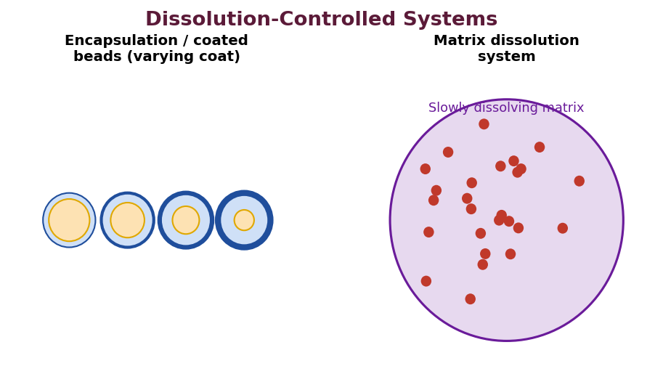
Fig. 5 : Encapsulation (coated beads) and matrix dissolution-controlled systems
(a) Encapsulation / Coating (Reservoir) dissolution systems
Drug particles or granules are coated with slowly dissolving polymers or waxes of varying thickness. Beads with thin coats dissolve early, those with thicker coats later, producing a sustained overall release (the principle of Spansule® capsules). Coating materials include cellulose derivatives, PEG, waxes and shellac.
(b) Matrix (monolithic) dissolution systems
Drug is dispersed uniformly in a slowly dissolving or erodible matrix (e.g., wax such as carnauba or castor wax, or a hydrophilic gum). As the matrix dissolves/erodes, drug is released. Prepared by fusion (congealing the drug in molten wax) or by aqueous/organic granulation.
2.4 Diffusion-Controlled Systems
Diffusion of the drug (rather than dissolution) is the rate-limiting step. Two sub-types exist : reservoir (membrane) and matrix (monolithic).
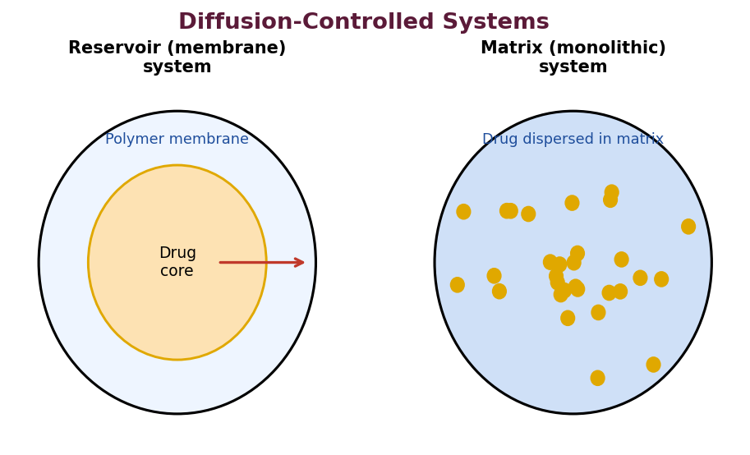
Fig. 6 : Reservoir (membrane) and matrix (monolithic) diffusion-controlled devices
(a) Reservoir (membrane) devices
A core of drug is enclosed within a rate-controlling polymer membrane. Drug dissolves at the inner surface and diffuses across the membrane. For a slab (film) the flux follows Fick's first law and yields a near constant (zero-order) release as long as the core remains saturated :
dQ/dt = (A × D × K × ΔC) / L
where A = area, D = diffusion coefficient in the membrane, K = partition coefficient of drug between membrane and core, ΔC = concentration difference and L = membrane thickness. Advantage : zero-order release possible. Disadvantage : risk of dose dumping if the membrane ruptures; membrane thickness must be reproducible.
(b) Matrix (monolithic) devices
Drug is dispersed uniformly throughout an insoluble polymer (e.g., ethylcellulose, PVC, polyethylene) or a hydrophilic matrix. Release from a homogeneous matrix follows the Higuchi equation and is proportional to the square-root of time :
Q = √[ D × Cs × (2A – Cs) × t ] (dispersed-drug, planar matrix)
where Q = amount released per unit area at time t, A = total drug content per unit volume and Cs = drug solubility in the matrix. Because release declines with √t, matrix systems are 'first-order-like' and do not give true zero-order release, but they are simple, cheap and free of dose-dumping risk.
Feature | Reservoir (membrane) | Matrix (monolithic)
Drug location | Core, surrounded by membrane | Dispersed throughout
Release order | Near zero-order | √t (Higuchi), declining
Dose dumping | Possible (membrane failure) | Unlikely
Fabrication | Coating / microencapsulation | Direct compression / granulation
Cost / complexity | Higher | Lower

2.5 Bio-erodible & Combination (Diffusion–Dissolution) Systems
In bio-erodible / biodegradable systems the polymer matrix gradually erodes in the biological environment and the drug is released by a combination of diffusion and erosion. An advantage is that no device residue remains to be removed. Erosion may be of two types :
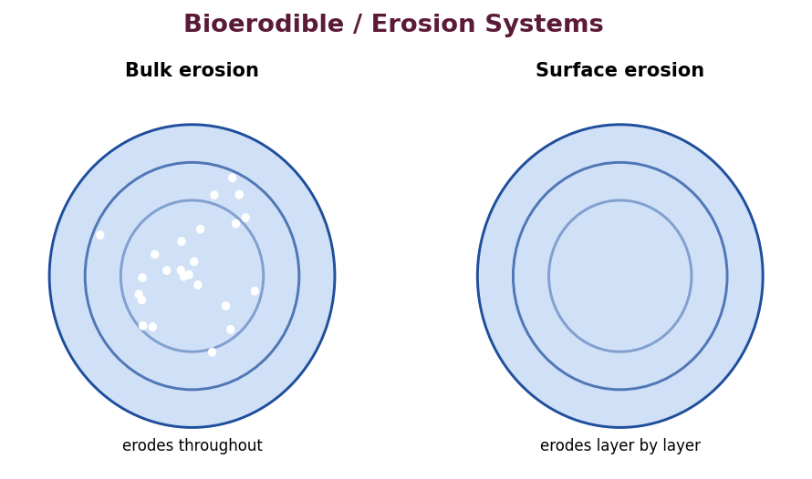
Fig. 7 : Bulk erosion vs surface erosion of a biodegradable matrix
➢ Bulk (homogeneous) erosion : water penetrates the whole matrix and degradation occurs throughout the bulk (e.g., poly-lactide/glycolide, PLGA). Size changes little until late.
➢ Surface (heterogeneous) erosion : degradation is confined to the surface and the device shrinks progressively while keeping its shape (e.g., polyanhydrides, poly-ortho-esters). Gives more nearly zero-order release.
Common biodegradable polymers : poly(lactic acid) (PLA), poly(lactic-co-glycolic acid) (PLGA), poly-ε-caprolactone, polyanhydrides, poly-ortho-esters and natural polymers (albumin, gelatin, chitosan). Erosion-controlled release is widely used for injectable microspheres and implants.
2.6 Osmotically Controlled Systems
Osmotic systems use the osmotic pressure developed by the imbibition of water across a semipermeable membrane as the driving force for delivery. They give a constant (zero-order) release that is essentially independent of the pH and hydrodynamics of the GI environment – their outstanding advantage.
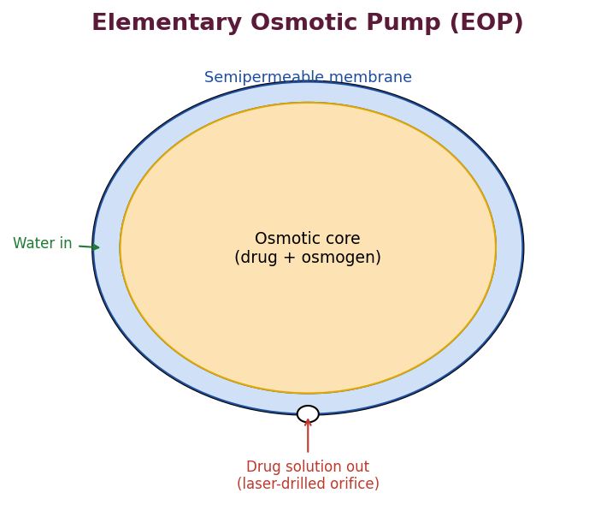
Fig. 8 : Elementary osmotic pump (EOP / OROS)
Elementary Osmotic Pump (EOP)
The EOP consists of an osmotic core (drug plus an osmotic agent such as NaCl, KCl, mannitol or lactose) surrounded by a rigid semipermeable membrane (usually cellulose acetate) that has a single small delivery orifice made by a laser. Water is imbibed osmotically, dissolving the core and generating hydrostatic pressure that pumps the saturated drug solution out through the orifice at a constant volume rate.
dM/dt = (A × Lp × σ × Δπ / h) × Cs
where A = membrane area, Lp = mechanical permeability, σ = reflection coefficient, Δπ = osmotic-pressure difference, h = membrane thickness and Cs = solubility of drug in the pumped solution. Delivery is constant while the core remains saturated.
Push-Pull Osmotic Pump (Bilayer, OROS Push-Pull)
For poorly soluble drugs a bilayer core is used : a drug layer and an osmotic 'push' layer (a swellable polymer such as polyethylene oxide). Imbibed water swells the push layer, which forces the drug layer (as a suspension) out of the orifice. This extends osmotic delivery to insoluble drugs. (Example : nifedipine GITS.)
★ Advantages of osmotic systems
• Zero-order release, independent of GI pH, motility and food.
• Good in-vitro / in-vivo correlation.
• Delivery rate can be programmed by membrane thickness, orifice size and osmogen.

2.7 Ion-Exchange Resin Systems
An ion-exchange resin is a water-insoluble cross-linked polymer bearing ionisable functional groups. An ionised drug is bound to the resin by exchanging with the resin's counter-ions, forming a drug–resin complex (resinate). In the GI tract, the abundant Na⁺, K⁺, H⁺ (for cationic drugs) or Cl⁻ (for anionic drugs) displace the drug, releasing it slowly.
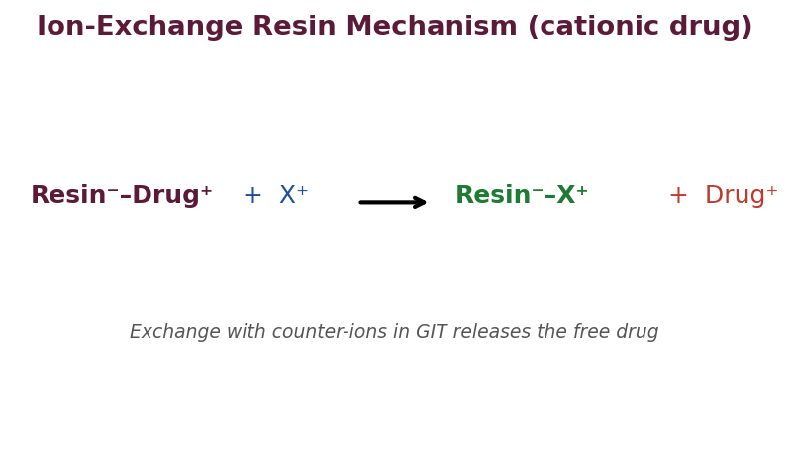
Fig. 9 : Release of a cationic drug from a drug–resin complex
Cationic (basic) drugs are bound to cation-exchange resins bearing –SO₃⁻ or –COO⁻ groups; anionic (acidic) drugs are bound to anion-exchange resins bearing quaternary ammonium groups. Release depends on the ionic environment (rather than pH alone), giving a fairly reproducible rate. Coating the resinate and further treatment (the 'Pennkinetic' system) improves control. Examples : nicotine–polacrilex, hydrocodone– and dextromethorphan–resin suspensions.
➢ Advantages : good for liquid SR suspensions; taste masking; protects drug; release relatively insensitive to enzymes.
➢ Limitations : release depends on variable GI ionic strength & diet; only ionisable drugs; drug–resin ratio limits loading.
2.8 Mucoadhesive (Bioadhesive) Drug Delivery Systems
Mucoadhesion is the ability of a material (usually a hydrophilic polymer) to adhere to the mucus layer of a biological surface, thereby prolonging the residence time of the dosage form at the site of absorption and intensifying contact. This is especially valuable for drugs with a narrow absorption window and for local action.
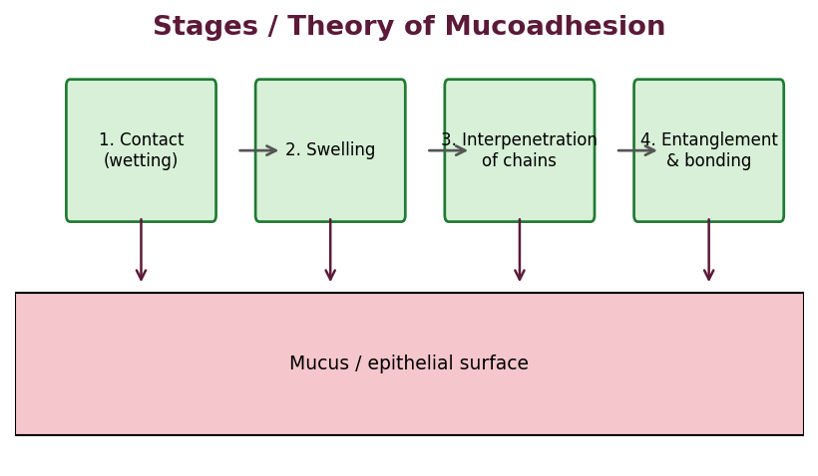
Fig. 10 : Stages / mechanism of mucoadhesion
Theories / mechanism of mucoadhesion
➢ Wetting theory : adhesive spreads and wets the mucosa (governed by spreading coefficient).
➢ Diffusion (interpenetration) theory : polymer chains and mucin chains inter-diffuse and entangle across the interface.
➢ Electronic theory : electron transfer forms an electrical double layer at the interface.
➢ Adsorption theory : adhesion by secondary forces – hydrogen bonds, van der Waals and hydrophobic interactions.
➢ Fracture theory : relates adhesive strength to the force required to separate the surfaces.
Ideal mucoadhesive polymer & examples
An ideal mucoadhesive polymer should have numerous hydrogen-bonding groups, high molecular weight, chain flexibility, appropriate charge and be biocompatible and non-toxic. Examples : carbopol (polyacrylic acid), sodium carboxymethylcellulose, HPMC, chitosan, sodium alginate, and thiolated polymers (thiomers).
Applications
➢ Buccal and sublingual tablets / films (bypass first-pass metabolism).
➢ Gastro-retentive mucoadhesive tablets for narrow-window drugs.
➢ Nasal, ocular and vaginal mucoadhesive systems.
➢ Colon-targeted and intestinal absorption enhancement.

2.9 Hydrophilic Matrix Systems & the Gel-Layer Concept
Hydrophilic matrix tablets (e.g., those based on HPMC) are the most popular oral SR platform because of their simplicity, low cost and safety. On contact with GI fluid the surface polymer hydrates and forms a viscous gel layer around the tablet. This gel layer controls both the diffusion of dissolved drug out of the matrix and the penetration of water in. Release therefore involves three simultaneous fronts :
➢ Swelling front : boundary between the dry glassy core and the rubbery gel.
➢ Diffusion front : boundary between undissolved and dissolved drug within the gel.
➢ Erosion front : outer boundary where the gel erodes into the medium.
Water-soluble drugs are released predominantly by diffusion through the gel (Higuchi kinetics), whereas poorly soluble drugs are released mainly by erosion of the gel (closer to zero-order). The release rate is governed by polymer type, viscosity grade, polymer : drug ratio, particle size and tablet geometry.
2.10 Factors Controlling Osmotic Delivery Rate
The delivery rate of an osmotic system can be programmed by adjusting the following variables, which makes osmotic pumps very versatile :
➢ Membrane permeability & thickness : thicker or less permeable membrane slows water influx and hence delivery.
➢ Membrane area : larger area increases the rate.
➢ Osmotic pressure of the core (osmogen) : higher osmotic pressure increases the driving force.
➢ Solubility of the drug in the pumped fluid : directly proportional to the amount delivered per unit volume.
➢ Size of the delivery orifice : must be within an optimum range – too small causes hydrostatic build-up, too large permits diffusion / burst.
Osmotic system | Feature | Suitable drug
Elementary (EOP) | Single core + orifice | Water-soluble
Push-pull (bilayer) | Drug layer + push layer | Poorly soluble
Controlled-porosity | Pore-formers in membrane | Various
Sandwiched (SOTS) | Two orifices, central drug | Various
Liquid OROS | Soft-gelatin liquid core | Liquid / lipophilic

2.11 Colon-Targeted Drug Delivery
Delivery to the colon is desirable for the local treatment of colonic diseases (ulcerative colitis, Crohn's disease, colon cancer) and for the systemic delivery of proteins / peptides that would be degraded in the upper GI. Because the colon is distal, several triggers are exploited to release drug specifically there :
➢ pH-dependent systems : coats (Eudragit S/L) that dissolve only at the higher pH of the terminal ileum / colon.
➢ Time-dependent (time-lagged) systems : release after a lag matching the small-intestinal transit time (~3–4 h after gastric emptying).
➢ Microbially triggered systems : use polysaccharides (pectin, guar gum, chitosan, amylose) or azo-polymers degraded specifically by colonic bacteria.
➢ Pressure-controlled systems : rupture under the higher luminal pressure of the colon.
2.12 Pulsatile (Time-Controlled) Delivery
Some diseases follow a circadian rhythm (e.g., early-morning asthma, angina, arthritis, hypertension) and are best treated by chronotherapy – delivering the drug in a pulse at the time of greatest need. Pulsatile systems release the drug rapidly after a programmed lag time. They may be rupturable (a swelling or effervescent core that bursts a coat), erodible-coat, or capsule-based (e.g., Pulsincap®).
2.13 Comparative Overview of Oral SR Mechanisms
Mechanism | Rate-limiting step | Typical kinetics | Advantage / limitation
Dissolution | Coat / matrix dissolution | First order | Simple / pH-sensitive
Diffusion (reservoir) | Membrane diffusion | Zero order | Constant / dose-dump risk
Diffusion (matrix) | Matrix diffusion | Higuchi (√t) | Cheap / declining rate
Osmotic | Water influx | Zero order | pH-independent / costly
Ion-exchange | Ionic exchange | Variable | Liquid SR / diet-dependent
Erosion | Polymer erosion | Near zero order | No residue / variable

★ High-yield – which mechanism gives zero-order?
• Osmotic pumps and (ideally) reservoir-membrane systems give true zero-order release.
• Matrix (monolithic) systems give √t (Higuchi) release – rate declines with time.
• Surface-erosion systems approach zero-order; bulk-erosion systems do not.

2.14 Diffusion Mathematics – Reservoir Geometries
The steady-state release rate from a reservoir device depends on its geometry. For the three common shapes, with a saturated core (constant activity), the rate is :
Slab (planar film)
dM/dt = A·D·K·ΔC / L (constant – zero order)
Cylinder
dM/dt = 2π·D·K·ΔC·L / ln(rₒ/rᵢ)
Sphere
dM/dt = 4π·D·K·ΔC·rₒ·rᵢ / (rₒ – rᵢ)
In every case, as long as the core remains saturated the concentration gradient is constant and release is zero-order; once the core is depleted below saturation, the gradient (and rate) falls.
2.15 Advantages & Limitations of each Mechanism
Diffusion systems
Advantages : reservoir types give zero-order release; well understood and predictable. Limitations : risk of dose dumping on membrane failure; potential for residual drug; reproducible membrane thickness required.
Dissolution systems
Advantages : simple and inexpensive; no membrane to rupture. Limitations : first-order (declining) release; sensitive to GI pH and to the dissolution environment.
Osmotic systems
Advantages : zero-order release independent of pH, food and motility; excellent IVIVC. Limitations : costly and technically demanding; require a laser-drilled orifice; the membrane and osmogen must be carefully engineered.
Ion-exchange systems
Advantages : useful for liquid SR suspensions and taste masking; protect the drug. Limitations : release depends on the variable ionic content of the diet; only ionisable drugs; loading limited by resin capacity.
2.16 Selection of System according to Drug Properties
Drug property | Preferred SR mechanism
Water-soluble, ionisable | Ion-exchange / osmotic
Poorly soluble | Push-pull osmotic / matrix
Narrow absorption window | Gastro-retentive / mucoadhesive
Needs constant level (zero order) | Osmotic / reservoir membrane
Low cost required | Hydrophilic matrix
Local colonic action | Colon-targeted (pH / microflora)

Unit III – Microencapsulation
3.1 Definition
Microencapsulation is the process by which small solid particles, liquid droplets or gases are enveloped within a thin coating of a wall-forming (shell) material to form small capsules (microcapsules) of size ranging from about 1 to 1000 µm. The material inside the capsule is the core (internal phase / fill) and the coating is the wall / shell (membrane).
Particles below 1 µm are called nanocapsules and those above 1000 µm are macrocapsules. When the drug is distributed uniformly throughout a polymer particle (no distinct core-shell), the product is a microsphere / micromatrix rather than a true microcapsule.
3.2 Objectives / Reasons for Microencapsulation
1. To achieve sustained or controlled release of the drug.
2. To mask the bitter taste or unpleasant odour of the drug.
3. To protect the core from environmental factors (light, moisture, oxygen) and improve stability.
4. To convert liquids into free-flowing powders (e.g., oils, vitamins).
5. To separate incompatible ingredients in a formulation.
6. To reduce gastric irritation (e.g., aspirin, KCl, ferrous salts).
7. To reduce volatility and hygroscopicity.
8. To achieve targeted or site-specific delivery.
9. To improve handling and flow properties of powders.
3.3 Types of Microcapsules / Microspheres
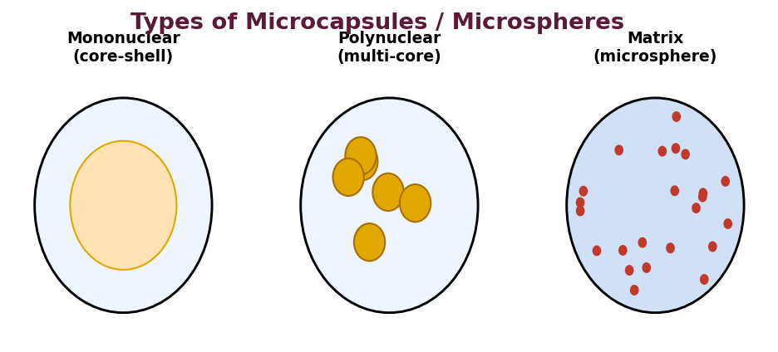
Fig. 11 : Mononuclear, polynuclear and matrix (microsphere) types
➢ Mononuclear (core-shell) : a single core enclosed by the shell.
➢ Polynuclear (multi-core) : several cores enclosed within a single shell.
➢ Matrix / microsphere : core material dispersed uniformly throughout the wall material.
3.4 Coating (Wall) Materials
The choice of coating material governs the release rate, protection and stability of the microcapsule. An ideal coating material should be capable of forming a coherent film, be chemically compatible and non-reactive with the core, provide the desired release characteristics, and be economical.
Category | Examples
Water-soluble polymers | Gelatin, gum acacia, starch, PVP, carboxymethylcellulose
Water-insoluble polymers | Ethylcellulose, polyethylene, polymethacrylate, cellulose nitrate
Enteric (pH-dependent) polymers | Cellulose acetate phthalate, shellac, zein, Eudragit L/S
Waxes & lipids | Beeswax, carnauba wax, stearic acid, glyceryl stearate
Proteins | Albumin, gelatin
Biodegradable polymers | PLA, PLGA, poly-ε-caprolactone, chitosan, alginate

3.5 Methods of Microencapsulation
The methods are broadly classified into physical, physico-chemical and chemical methods.
(a) Coacervation – Phase Separation
This is the classical and most widely used method. It involves three steps : (i) formation of three immiscible phases – the liquid vehicle, the core material and the coating material; (ii) deposition of the liquid polymer coating on the core; and (iii) rigidisation of the coating by thermal, cross-linking or desolvation techniques. Coacervation may be simple (one polymer, phase separation induced by a non-solvent, salt or temperature change) or complex (two oppositely charged polymers, e.g., gelatin–acacia, whose interaction produces the coacervate).
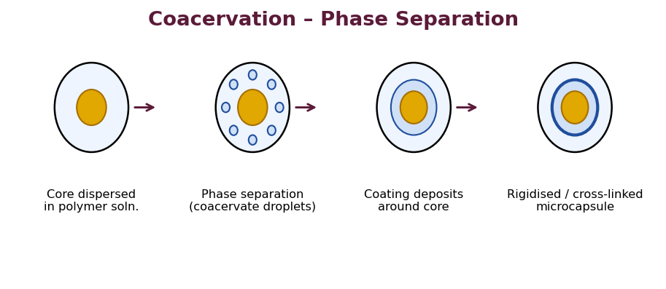
Fig. 12 : Steps of coacervation / phase-separation microencapsulation
(b) Spray Drying
The core is dispersed / dissolved in a solution of the coating polymer; the mixture is atomised into a stream of hot air. The solvent evaporates instantly and dry microcapsules are collected in a cyclone. It is rapid, single-step and economical, and suitable for heat-sensitive materials because exposure to heat is very brief.
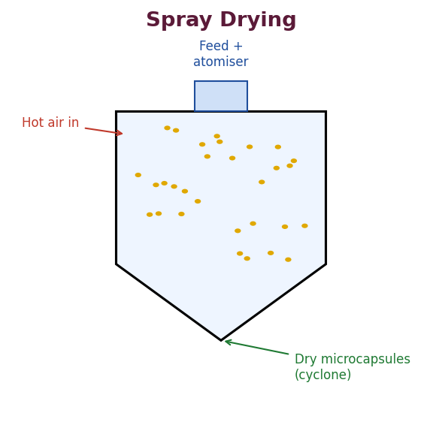
Fig. 13 : Spray-drying microencapsulation
(c) Air-Suspension Coating (Wurster process) & Pan Coating
In pan coating, the solid cores (larger particles / tablets) are tumbled in a coating pan while the coating solution is sprayed and warm air dries the film. In the Wurster air-suspension technique, particles are suspended in an upward stream of air and the coating is sprayed and dried repeatedly as the particles circulate – giving very uniform films, ideal for controlled release.
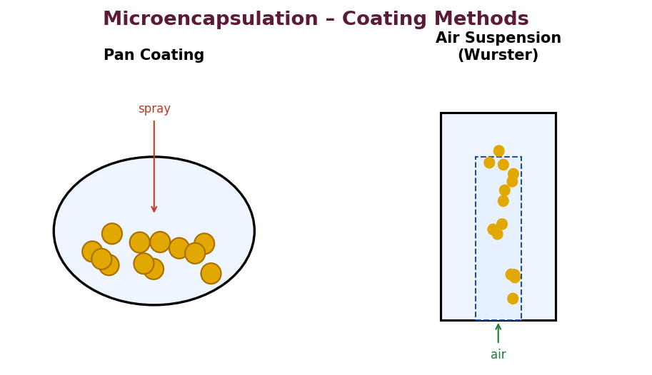
Fig. 14 : Pan coating and air-suspension (Wurster) coating
(d) Other methods
➢ Solvent evaporation : polymer and drug are dissolved in a volatile organic solvent, emulsified in an aqueous phase and the solvent evaporated to harden the microspheres (common for PLGA microspheres).
➢ Emulsification–cross-linking / ionotropic gelation : e.g., alginate droplets gelled with calcium chloride; chitosan cross-linked with tripolyphosphate.
➢ Interfacial & in-situ polymerisation : the shell is formed by polymerisation of monomers at the core surface.
➢ Spray congealing : a molten wax–drug dispersion is sprayed into cool air where it congeals.
➢ Multiorifice-centrifugal & pan-drying techniques.
3.6 Release & Stability Kinetics
Drug release from microcapsules occurs by diffusion through the wall, by dissolution / erosion of the wall, or by osmotic rupture. The release data are commonly fitted to kinetic models :
➢ Zero-order : constant amount released per unit time (ideal CR).
➢ First-order : release proportional to the amount remaining.
➢ Higuchi model : release proportional to √t (matrix diffusion).
➢ Korsmeyer–Peppas : Mt/M∞ = k·tⁿ; the exponent n indicates the mechanism (Fickian diffusion when n ≤ 0.43 for spheres; anomalous / non-Fickian for intermediate n; case-II / erosion when n → 0.85).
Stability kinetics assess how the encapsulated drug degrades on storage. Because the coat protects the core from moisture, oxygen and light, microencapsulation usually increases the shelf-life; the degradation still follows the appropriate reaction order and can be predicted from accelerated data using the Arrhenius relationship.
3.7 Evaluation of Microcapsules
➢ Particle size & shape : microscopy, sieving, laser diffraction, SEM.
➢ Surface morphology : scanning electron microscopy (SEM).
➢ Wall thickness & core-shell structure.
➢ Drug content / loading & encapsulation efficiency.
➢ Flow properties : angle of repose, Carr's index, Hausner ratio.
➢ In-vitro drug release / dissolution and kinetic modelling.
➢ Isolation & envelope characteristics; residual solvent.
% Encapsulation efficiency = (Actual drug content / Theoretical drug content) × 100
3.8 Applications of Microencapsulation
➢ Sustained / controlled release of drugs (e.g., aspirin, KCl, theophylline).
➢ Taste and odour masking (e.g., paracetamol, chloramphenicol).
➢ Protection of unstable drugs (vitamins, prostaglandins).
➢ Conversion of liquids to solids (cod-liver oil, vitamin A/E).
➢ Separation of incompatible substances.
➢ Reduction of gastric irritation and toxicity.
➢ Preparation of injectable depot microspheres (leuprolide PLGA).
➢ Use in carbonless copy paper, cosmetics and food industries.

3.9 Classification of Microencapsulation Methods
The many techniques are conveniently grouped as physical, physico-chemical and chemical methods according to the principle by which the wall is formed around the core.
Class | Methods
Physical / mechanical | Spray drying, spray congealing, air-suspension (Wurster) coating, pan coating, multiorifice-centrifugal, fluid-bed coating
Physico-chemical | Simple & complex coacervation, solvent evaporation, ionotropic gelation, supercritical-fluid, layer-by-layer
Chemical | Interfacial polymerisation, in-situ polymerisation, polycondensation

Simple vs Complex Coacervation
Feature | Simple coacervation | Complex coacervation
Number of polymers | One | Two (oppositely charged)
Driving force | Desolvation (salt, alcohol, heat) | Electrostatic attraction
Typical system | Gelatin + sodium sulphate | Gelatin (+) + acacia (−)
pH dependence | Low | Strongly pH-dependent

In complex coacervation, the pH is adjusted below the isoelectric point of gelatin so that gelatin becomes positively charged and interacts with negatively charged acacia; the neutralised complex separates as a coacervate that deposits around the core. The coating is then hardened (cross-linked) with formaldehyde or glutaraldehyde and cooling.
3.10 Factors affecting Microencapsulation & Release
➢ Core : coat ratio : influences wall thickness and hence release rate.
➢ Wall material & its molecular weight : determine permeability and mechanical strength.
➢ Particle size of the core : smaller cores give larger surface area and faster release.
➢ Method & process variables : temperature, stirring speed, rate of addition of non-solvent, pH.
➢ Solvent & hardening conditions.
➢ Cross-linking density : higher cross-linking slows release.
3.11 Microspheres in Advanced Delivery
Polymeric microspheres (matrix type) are extensively used as injectable depot systems and as carriers for targeted delivery. Biodegradable PLGA microspheres of peptides (leuprolide, octreotide, triptorelin) provide once-monthly to once-3-monthly therapy. Albumin and starch microspheres, magnetic microspheres and mucoadhesive microspheres extend the concept to targeting. Bio-adhesive microspheres prolong residence at mucosal sites; magnetic microspheres can be localised by an external magnetic field.
3.12 Marketed / Representative Products
Product principle | Example
Taste-masked micro-capsules | Micro-encapsulated paracetamol / aspirin
Sustained-release beads | Theo-Dur®, Spansule® capsules
Depot PLGA microspheres | Lupron Depot® (leuprolide)
Enteric micro-capsules | Enteric-coated omeprazole pellets

★ High-yield – Microencapsulation
• Size range 1–1000 µm; below 1 µm = nanocapsule.
• Complex coacervation classic pair = gelatin + acacia (gum arabic); hardened with glutaraldehyde.
• Spray drying = fastest, single-step, good for heat-labile drugs (brief heat exposure).
• Encapsulation efficiency = actual / theoretical drug content × 100.

3.13 Interfacial & In-situ Polymerisation
In interfacial polymerisation, two reactive monomers (one water-soluble, one oil-soluble) react at the interface of an emulsion droplet to form a polymeric membrane around the core (e.g., polyamide / nylon shells by the reaction of a diamine with a diacid chloride). In in-situ polymerisation the monomer is supplied from one phase only and polymerises on the core surface. Both give thin, uniform walls but may leave traces of reactive monomer, which must be controlled.
3.14 Solvent Evaporation & Ionotropic Gelation – Detail
In the solvent-evaporation (emulsion) method, the polymer (e.g., PLGA, ethylcellulose) and drug are dissolved in a volatile, water-immiscible solvent (dichloromethane); this organic phase is emulsified into an aqueous phase containing a stabiliser (PVA). Continuous stirring and gentle heat evaporate the solvent, hardening the droplets into microspheres, which are washed and dried. It is the standard route to biodegradable PLGA microspheres.
In ionotropic gelation, a solution of a polyelectrolyte (sodium alginate or chitosan) containing the drug is dropped into a solution of a counter-ion (calcium chloride or tripolyphosphate); instantaneous cross-linking forms gelled beads. It is mild, aqueous and free of organic solvents – ideal for proteins and cells.
3.15 Multiorifice-Centrifugal & Fluidised-Bed Methods
In the multiorifice-centrifugal process (developed by the Southwest Research Institute), core and coating are passed through a rotating cylinder with orifices; centrifugal force ejects coated droplets that solidify in flight. Fluidised-bed / Wurster coating suspends the cores in an air stream and sprays the coating repeatedly, giving very uniform films, and is widely used industrially for controlled-release pellets.
3.16 Nanoparticles & Nanocapsules (brief)
When the particle size is reduced below 1 µm, the product is a nanoparticle (matrix) or nanocapsule (reservoir). The very large surface area, the ability to cross biological barriers and the possibility of surface functionalisation make nanoparticles important for targeted and intracellular delivery, although the general principles of wall material and release kinetics remain those of microencapsulation.

Unit IV – Implants and Inserts
4.1 Introduction & Definition
An implant is a sterile, solid dosage form (device) of a suitable size and shape that is placed into the body – usually subcutaneously or intramuscularly – by injection or surgical insertion, where it releases the drug over a prolonged period (weeks to years). An insert is a similar rate-controlled device placed into a body cavity or orifice such as the eye (ocular insert), vagina (vaginal ring) or uterus (intra-uterine device).
Implants and inserts are the ultimate long-acting controlled-release systems. Because they bypass the GI tract, they avoid first-pass metabolism and GI degradation, deliver at a constant (often zero-order) rate, and dramatically improve patient compliance (a single insertion may last months). Their chief limitations are the need for a minor surgical / invasive procedure for insertion (and sometimes removal), the risk of local tissue reaction, and the difficulty of terminating therapy abruptly.
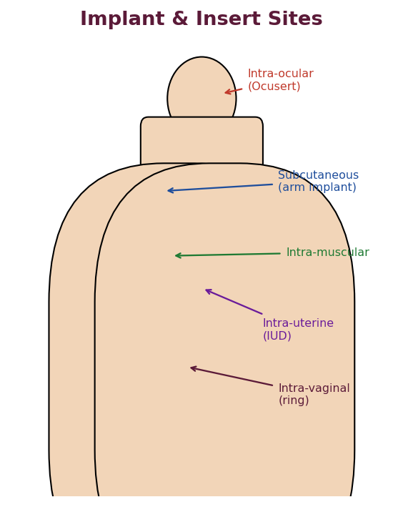
Fig. 15 : Common sites for implants and inserts in the body
Classification of implantable systems
➢ Non-biodegradable implants : made of inert polymers (silicone / PDMS, ethylene-vinyl acetate, polyurethane); must be surgically removed after use (e.g., Norplant®).
➢ Biodegradable implants : made of erodible polymers (PLA, PLGA, polyanhydrides); do not require removal (e.g., Zoladex®, Gliadel® wafer).
➢ Pump / osmotic implants : e.g., the DUROS® osmotic implant and implantable infusion pumps that deliver at a programmable rate.
4.2 Biocompatibility : Reaction of Host to Implant & Implant to Host
Biocompatibility is the ability of a material to perform with an appropriate host response in a specific application. Because an implant is a foreign body, the tissue and the implant interact in two directions.
Reaction of the Host to the Implant (tissue response)
When a device is implanted it causes injury and initiates the classical foreign-body reaction, which proceeds through the following overlapping stages :
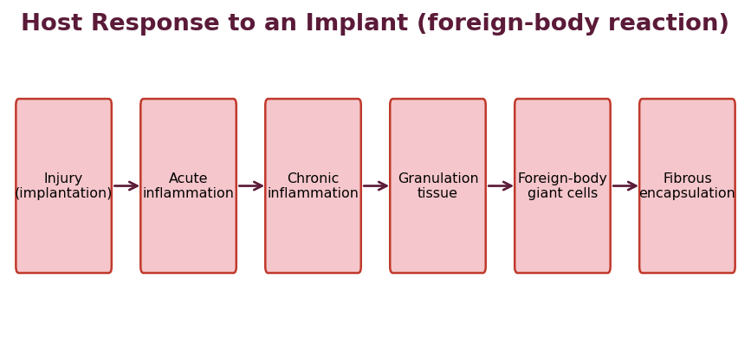
Fig. 16 : Sequence of host response (foreign-body reaction) to an implant
1. Injury & protein adsorption : implantation injures tissue; blood proteins immediately adsorb onto the surface forming a provisional matrix.
2. Acute inflammation : neutrophils and exudate arrive (minutes to days).
3. Chronic inflammation : monocytes / macrophages and lymphocytes predominate (days to weeks).
4. Granulation tissue : fibroblasts and new capillaries proliferate.
5. Foreign-body giant cells : macrophages fuse on the surface in an attempt to engulf the implant.
6. Fibrous encapsulation : a collagenous fibrous capsule walls off the implant. A thick capsule can act as an additional diffusion barrier and slow release.
The intensity of this response depends on the size, shape, surface chemistry, roughness, degradation products and the movement of the implant. A biocompatible material provokes only a thin, quiescent capsule.
Reaction of the Implant to the Host (material response)
Conversely, the biological environment acts on the implant : body fluids, enzymes, pH, ions and mechanical stress can cause the material to degrade, swell, corrode, leach additives, absorb lipids or lose mechanical strength. For biodegradable implants this degradation is intentional and controlled; for non-biodegradable implants any degradation is undesirable and may release toxic products. The degradation products must be non-toxic, non-carcinogenic and readily eliminated.
★ Requirements of an ideal implant material
• Biocompatible, non-toxic, non-carcinogenic and non-allergenic.
• Chemically & physically stable (or predictably biodegradable) in the body.
• Adequate mechanical strength; easy to sterilise; able to give the desired release rate.
• Degradation products (if any) must be safe and eliminable.

4.3 Subcutaneous Implants
Subcutaneous implants are small rods, pellets, capsules or discs inserted under the skin (usually of the upper arm) using a trocar or a minor incision. Because the subcutaneous tissue is relatively avascular and easily accessible, it is the preferred site for long-acting implants; insertion and removal are simple.
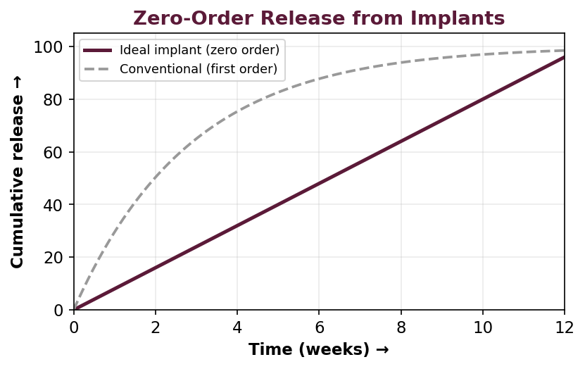
Fig. 17 : Zero-order release characteristic of a well-designed implant
Design types
➢ Reservoir (membrane) implants : a drug core within a rate-controlling silicone or EVA membrane – gives near zero-order release (e.g., Norplant® levonorgestrel rods; Implanon® / Nexplanon® etonogestrel).
➢ Matrix (monolithic) implants : drug dispersed in a polymer rod; release declines with √t.
➢ Biodegradable implants : e.g., Zoladex® (goserelin in PLGA depot) for prostate cancer; no removal needed.
Applications
➢ Long-acting contraception (levonorgestrel, etonogestrel implants – up to 3–5 yr).
➢ Hormone therapy (testosterone, estradiol pellets).
➢ Cancer therapy (goserelin, leuprolide depots).
➢ Narcotic antagonist / de-addiction (naltrexone implants).
4.4 Intramuscular Implants & Depot Injections
The intramuscular site is highly vascular, so absorption is faster than from the subcutaneous site; it is therefore used for injectable depot systems (oily solutions, aqueous suspensions, microspheres and in-situ forming implants) rather than for solid rods that would be difficult to remove. Drug is released slowly by dissolution / partitioning from the depot.
➢ Oily / esterified depots : lipophilic esters in an oily vehicle (e.g., testosterone enanthate, fluphenazine decanoate) release drug over weeks.
➢ Aqueous microcrystalline suspensions : e.g., procaine penicillin, medroxyprogesterone acetate (Depo-Provera®).
➢ Biodegradable microspheres : PLGA microspheres of leuprolide (Lupron Depot®).
➢ In-situ forming implants : a polymer solution that solidifies into a depot on injection (e.g., Atrigel®, Eligard® leuprolide).
4.5 Intra-ocular Inserts
Conventional eye drops have very poor ocular bioavailability (< 5 %) because of rapid drainage, tear turnover and naso-lacrimal loss, and give large pulses in concentration. Ocular inserts are solid or semisolid rate-controlled devices placed in the cul-de-sac (conjunctival sac) that release drug at a constant rate for prolonged periods, greatly improving bioavailability and patient compliance.
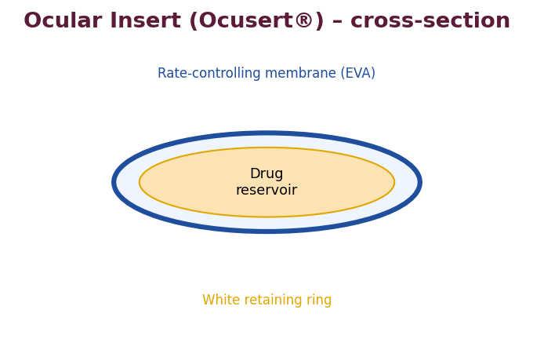
Fig. 18 : Ocusert® reservoir-type ocular insert (cross-section)
Classification of ocular inserts
➢ Insoluble inserts : reservoir (Ocusert® Pilo – pilocarpine between two EVA membranes for glaucoma; zero-order for 7 days) and diffusional / osmotic types; must be removed.
➢ Soluble inserts : made of soluble natural or synthetic polymers (e.g., SODI®, Lacrisert® hydroxypropylcellulose) that dissolve and need no removal.
➢ Bio-erodible inserts : made of erodible polymers.
Advantages : prolonged contact and increased bioavailability, accurate dosing, reduced systemic side effects and better compliance. Disadvantages : foreign-body sensation, occasional movement / loss of the insert and difficulty of self-insertion.
4.6 Intra-vaginal Inserts (Vaginal Rings)
The vaginal mucosa is richly vascularised and permeable, allowing systemic delivery that avoids the GI tract and first-pass metabolism, as well as local therapy. Vaginal rings are flexible, doughnut-shaped elastomeric (silicone / EVA) devices that a woman can insert and remove herself and that release steroids at a controlled rate for weeks to months.
➢ Reservoir / core rings : drug core surrounded by a rate-controlling sheath.
➢ Matrix rings : drug dispersed throughout the elastomer.
➢ Examples : NuvaRing® (etonogestrel + ethinyl-estradiol, monthly contraception); Estring® / Femring® (estradiol for menopausal therapy).
4.7 Intra-uterine Systems (IUDs / IUS)
Intra-uterine devices deliver drug directly to the uterine cavity, giving high local concentration with minimal systemic exposure, for very long durations (up to 5–10 years). Modern medicated intra-uterine systems combine the mechanical contraceptive action of the device with the pharmacological action of a released agent.
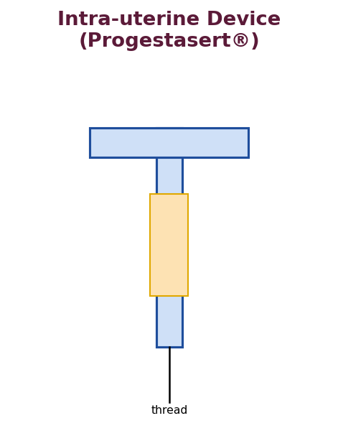
Fig. 19 : T-shaped medicated intra-uterine system (Progestasert® type)
➢ Progesterone-releasing IUS : Progestasert® released progesterone from a T-shaped reservoir for ~1 year.
➢ Levonorgestrel IUS : Mirena® releases levonorgestrel for up to 5 years; used for contraception and menorrhagia.
➢ Copper IUDs : release cupric ions that are spermicidal (e.g., CuT-380A).
Advantages : very long action, high compliance, reversible, local action with low systemic levels. Disadvantages : insertion by a trained professional, risk of expulsion, uterine irritation, cramping or bleeding.
4.8 Comparative Summary of Implant / Insert Sites
Site | Typical system | Duration | Example
Subcutaneous | Reservoir / matrix rod | Months–years | Norplant, Implanon
Intramuscular | Depot injection / microspheres | Weeks–months | Lupron Depot
Intra-ocular | Reservoir insert | Up to 1 week+ | Ocusert Pilo
Intra-vaginal | Elastomeric ring | Weeks–months | NuvaRing, Estring
Intra-uterine | Medicated T-device | 1–10 years | Mirena, Progestasert

4.9 Advantages & Disadvantages of Implantable Systems
Advantages
➢ Very long duration of action (weeks to years) from a single administration.
➢ Constant, often zero-order release and predictable plasma levels.
➢ Bypass first-pass metabolism and GI degradation.
➢ Excellent patient compliance; useful when oral therapy is unreliable.
➢ Localised delivery with high local and low systemic concentration (inserts).
➢ Lower total dose and fewer systemic side effects.
Disadvantages
➢ Require a minor surgical / invasive procedure for insertion (and removal of non-degradable types).
➢ Risk of local tissue reaction, infection or fibrous encapsulation.
➢ Difficult to terminate therapy quickly (device must be removed).
➢ Possibility of dose dumping if a reservoir membrane ruptures.
➢ Patient acceptability and cost.
4.10 Biodegradable Polymers for Implants
Biodegradable implants avoid the need for surgical removal. The most important polymers are the aliphatic polyesters PLA, PGA and their copolymer PLGA, which hydrolyse to lactic and glycolic acids that enter normal metabolic pathways.
➢ PLA / PGA / PLGA : degrade by bulk hydrolysis of ester bonds; the lactide : glycolide ratio and molecular weight control the degradation time (weeks to months). Higher glycolide content degrades faster.
➢ Polyanhydrides & poly-ortho-esters : degrade by surface erosion, giving more nearly zero-order release (e.g., Gliadel® carmustine wafer for brain tumours).
➢ Poly-ε-caprolactone : very slow degradation – suited to long-term (> 1 yr) systems (e.g., Capronor® contraceptive).
➢ Natural polymers : collagen, gelatin, albumin and chitosan.
4.11 In-Situ Forming Implants
These are injectable liquid systems that transform into a solid or semisolid depot after administration, avoiding surgery. Formation can be triggered by :
➢ Solvent removal / phase inversion : a polymer (PLGA) dissolved in a biocompatible solvent (NMP) precipitates as the solvent diffuses away (Atrigel® / Eligard®).
➢ Thermal gelation : a polymer solution (e.g., poloxamer) that is liquid at room temperature and gels at body temperature.
➢ In-situ cross-linking : chemical or photo cross-linking after injection.
➢ Ionic gelation : alginate gelling with body calcium.
4.12 Implantable Pumps
Implantable pumps deliver drug at a programmable or constant rate for very long periods :
➢ Osmotic implantable pumps : the DUROS® system and the ALZET® research pump use osmosis to deliver at a constant rate for months (e.g., Viadur® leuprolide for 12 months).
➢ Infusion / peristaltic pumps : electromechanical pumps for insulin, chemotherapy or intrathecal analgesia (baclofen, morphine).
➢ Programmable pumps : allow the rate to be changed non-invasively by telemetry.
4.13 Sterilisation & Evaluation of Implants
Because implants are placed in sterile tissue, they must themselves be sterile and free of pyrogens. Terminal sterilisation is preferred; heat-labile biodegradable polymers are often sterilised by gamma-irradiation or aseptically processed. Gamma-irradiation, however, can accelerate degradation of PLGA and must be validated.
Evaluation
➢ Physical : dimensions, weight, surface morphology (SEM), mechanical strength.
➢ Drug content & uniformity.
➢ In-vitro release : in a suitable medium, fitted to kinetic models; accelerated release testing at elevated temperature.
➢ Degradation studies : molecular-weight loss, mass loss, morphology over time (for biodegradable types).
➢ Sterility & pyrogen (endotoxin) tests.
➢ Biocompatibility / tissue-irritation studies in animals.
➢ In-vivo release & pharmacokinetics.
4.14 Representative Marketed Implants & Inserts
Product | Drug / use | Type
Norplant® | Levonorgestrel (contraception) | Non-degradable s.c. rods
Implanon / Nexplanon® | Etonogestrel (contraception) | s.c. rod
Zoladex® | Goserelin (prostate cancer) | Biodegradable s.c. depot
Gliadel® wafer | Carmustine (brain tumour) | Biodegradable (polyanhydride)
Ocusert® Pilo | Pilocarpine (glaucoma) | Ocular reservoir insert
Vitrasert® | Ganciclovir (CMV retinitis) | Intra-ocular implant
Mirena® | Levonorgestrel (5 yr) | Intra-uterine system
NuvaRing® | Etonogestrel + estrogen | Vaginal ring

★ High-yield – Implants & Inserts
• Foreign-body reaction ends in fibrous encapsulation – a thick capsule slows release.
• PLGA = bulk erosion; polyanhydrides / poly-ortho-esters = surface erosion (nearer zero-order).
• Ocusert delivers pilocarpine at zero-order for 7 days using EVA membranes.
• Mirena (levonorgestrel IUS) acts up to 5 years; Progestasert released progesterone for ~1 year.

4.15 Ocular Anatomy & Barriers to Ocular Delivery
The design of ocular inserts is dictated by the anatomy and protective mechanisms of the eye, which make conventional topical delivery very inefficient.
Pre-corneal factors limiting bioavailability
➢ Rapid solution drainage : the eye holds only ~7–10 µL; an instilled drop (~50 µL) is largely lost by drainage within minutes.
➢ Tear turnover & dilution : tears are replaced at ~16 % per minute, diluting and washing away the drug.
➢ Naso-lacrimal drainage : drug drains into the nasolacrimal duct and can be absorbed systemically, causing side effects.
➢ Non-productive absorption : loss to the conjunctiva and sclera.
➢ Corneal barrier : the cornea (lipophilic epithelium – hydrophilic stroma – lipophilic endothelium) requires the drug to be both lipophilic and hydrophilic (amphiphilic) to penetrate.
Consequently, ocular bioavailability from drops is typically < 5 %. Ocular inserts overcome this by providing prolonged, controlled contact, thereby increasing bioavailability, reducing dosing frequency and lowering systemic side effects.
The Ocusert system in detail
The Ocusert® Pilo-20 / Pilo-40 is a flat, flexible, elliptical reservoir insert. A core of pilocarpine gelled with alginic acid is sandwiched between two rate-controlling ethylene-vinyl acetate (EVA) membranes and bordered by a titanium-dioxide-filled white retaining ring for visibility. It is placed in the conjunctival cul-de-sac and delivers pilocarpine at a constant rate (20 or 40 µg/h) for 7 days for the control of glaucoma, replacing four-times-daily drops.
4.16 Vaginal Route – Anatomy & Advantages
The vaginal epithelium is a stratified squamous mucosa richly supplied with blood; drug absorbed here enters the systemic circulation directly, avoiding hepatic first-pass metabolism. Permeability varies with the menstrual cycle (thickness and hydration change with oestrogen). The route is used both for local action (antifungals, spermicides) and for systemic hormone delivery. Advantages : self-insertion and removal, avoidance of first-pass, prolonged controlled release from rings, and reversibility. Limitations : cultural acceptability, local irritation, influence of cycle and discharge, and gender specificity.
4.17 Intra-uterine Route – Mechanism & History
Intra-uterine devices exploit the uterus as a site for very long-term local delivery. The earliest inert IUDs (Lippes loop) acted purely mechanically. Medicated systems greatly improved efficacy and reduced side effects :
➢ Copper IUDs (CuT-380A) : release cupric ions that are toxic to sperm and impair implantation; effective for up to 10 years.
➢ Progesterone IUS (Progestasert®) : a T-shaped device releasing 65 µg/day progesterone from an ethylene-vinyl acetate reservoir for ~1 year; thickens cervical mucus and thins the endometrium.
➢ Levonorgestrel IUS (Mirena®) : releases ~20 µg/day levonorgestrel for up to 5 years; also used to treat menorrhagia.
Advantages : extremely long action, high compliance, reversible, high local with low systemic exposure. Disadvantages : professional insertion, risk of expulsion, perforation, cramping, irregular bleeding and pelvic infection.
4.18 Subcutaneous vs Intramuscular – Comparison
Feature | Subcutaneous | Intramuscular
Vascularity | Lower (slower absorption) | Higher (faster absorption)
Preferred form | Solid rods / implants | Depot injections / microspheres
Removal | Possible (non-degradable) | Not practical
Volume tolerated | Small | Larger
Example | Norplant, Implanon | Depo-Provera, Lupron Depot

4.19 Ideal Requirements of Implants & Inserts
➢ Deliver the drug at the required (often zero-order) rate for the intended duration.
➢ Be biocompatible and cause minimal tissue reaction.
➢ Be sterile, pyrogen-free and of reproducible quality.
➢ Be small and comfortable enough for the site; easy to insert (and remove if non-degradable).
➢ For biodegradable types, degrade completely into safe, eliminable products.
➢ Be physically and chemically stable during manufacture, sterilisation and storage.

Unit V – Transdermal Drug Delivery Systems
5.1 Introduction & Definition
A transdermal drug delivery system (TDDS) is a self-contained, discrete dosage form (a 'patch') which, when applied to the intact skin, delivers the drug through the skin at a controlled rate into the systemic circulation. It provides a non-invasive, painless and continuous route that bypasses the gastrointestinal tract and hepatic first-pass metabolism.
Advantages
➢ Avoids first-pass metabolism and GI degradation / irritation.
➢ Provides controlled, constant (often zero-order) plasma levels for a prolonged time.
➢ Reduces dosing frequency and improves compliance.
➢ Therapy can be terminated simply by removing the patch.
➢ Useful for drugs with a short half-life and narrow therapeutic index.
➢ Suitable for unconscious or nauseated patients.
Disadvantages / Limitations
➢ Only potent drugs (dose usually < 10–20 mg/day) can be delivered because skin permeability is limited.
➢ The stratum corneum is a formidable barrier – large or hydrophilic molecules permeate poorly.
➢ Possibility of local skin irritation, erythema or sensitisation.
➢ Not suitable for drugs that irritate the skin or are extensively metabolised in skin.
➢ Comparatively expensive; adhesion problems with sweat / movement.
5.2 Fundamentals of Skin Permeation
The skin comprises three principal layers : the epidermis (whose outermost, dead, keratinised layer, the stratum corneum, is the main permeation barrier), the dermis (vascularised connective tissue containing the capillaries that carry absorbed drug away), and the subcutaneous fat. The stratum corneum behaves as a 'brick-and-mortar' structure – keratin-filled corneocytes (bricks) embedded in intercellular lipid lamellae (mortar).
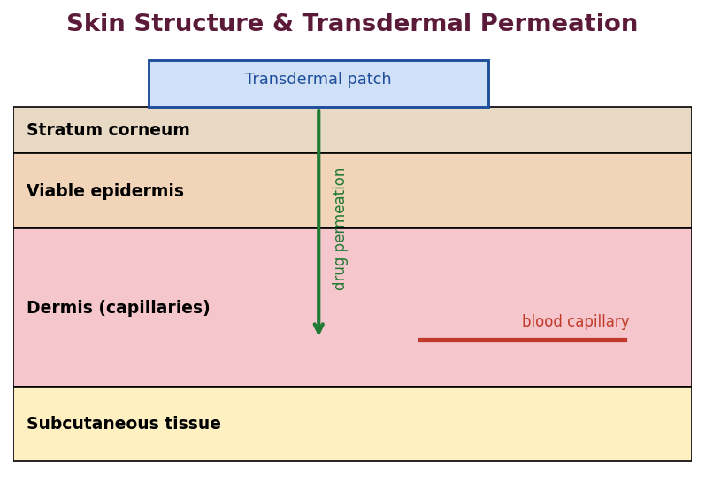
Fig. 20 : Structure of skin and the path of transdermal permeation
Routes of permeation across the skin
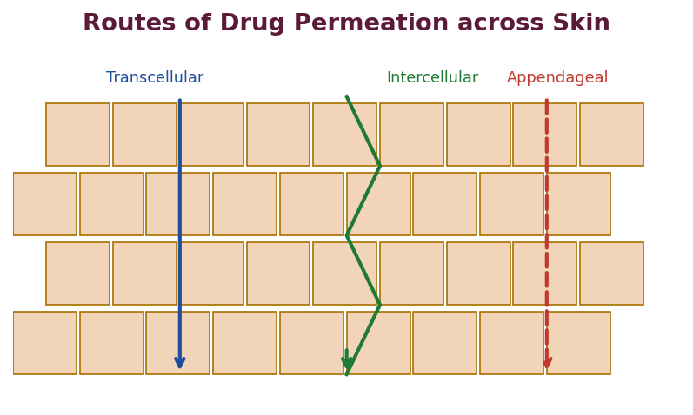
Fig. 21 : Transcellular, intercellular and appendageal routes of skin permeation
➢ Transcellular (intracellular) route : directly through the corneocytes and lipid – requires repeated partitioning; shorter path but many barriers.
➢ Intercellular route : through the tortuous lipid matrix between corneocytes – the predominant pathway for most drugs.
➢ Appendageal (trans-follicular) route : through hair follicles, sebaceous and sweat glands – a minor pathway (~0.1 % of surface area) but important early and for ions / large molecules.
Permeation kinetics – Fick's law, flux and lag time
Steady-state permeation across the skin obeys Fick's first law of diffusion :
Jₛₛ = (D × K × ΔC) / h = P × ΔC
where Jₛₛ = steady-state flux, D = diffusion coefficient in the stratum corneum, K = partition coefficient (skin/vehicle), ΔC = concentration gradient, h = thickness of the barrier and P = permeability coefficient (P = D·K/h). The cumulative amount permeated plotted against time is linear at steady state; extrapolation of this line to the time-axis gives the lag time :
Lag time tₗ = h² / (6 × D)
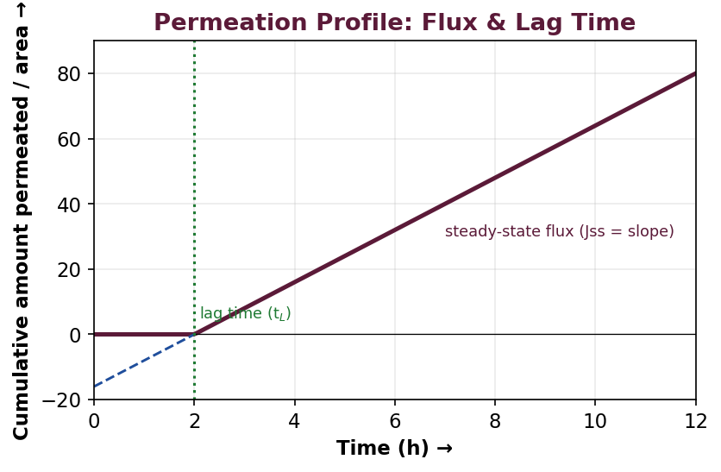
Fig. 22 : Permeation profile showing steady-state flux (slope) and lag time
5.3 Approaches / Penetration Enhancement
Because the stratum corneum limits delivery, several chemical, physical and formulation approaches are used to enhance permeation.
(a) Chemical penetration enhancers
These reversibly reduce the barrier resistance of the stratum corneum by disrupting the ordered lipid, increasing drug partitioning or fluidising the membrane. Examples : water, alcohols (ethanol), sulphoxides (DMSO), fatty acids (oleic acid), Azone (laurocapram), surfactants, terpenes, propylene glycol and urea.
(b) Physical / active enhancement techniques
➢ Iontophoresis : application of a small electric current to drive ionised / charged drug molecules across the skin (electro-repulsion) and to induce electro-osmotic flow. Delivery is proportional to the current and can be switched on/off – giving programmable delivery (e.g., lidocaine, pilocarpine).
➢ Sonophoresis (phonophoresis) : use of ultrasound to enhance permeation. Low-frequency ultrasound produces cavitation that transiently disrupts the stratum corneum lipids, greatly increasing permeability, even of macromolecules such as insulin.
➢ Electroporation : short high-voltage pulses create transient aqueous pores in the lipid bilayers.
➢ Microneedles : micron-sized needles painlessly create micro-channels through the stratum corneum.
➢ Others : magnetophoresis, thermal / laser ablation, needle-free jet injection.
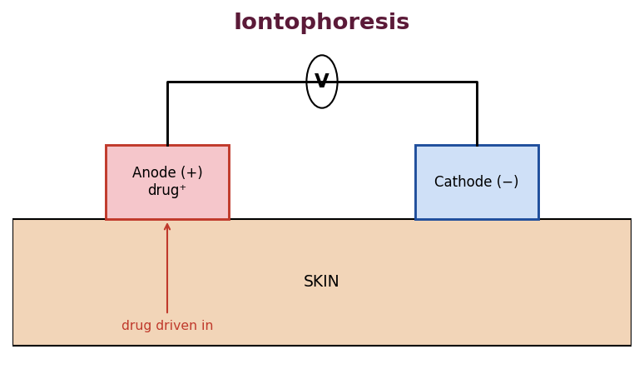
Fig. 23 : Iontophoresis – electrically assisted transdermal delivery
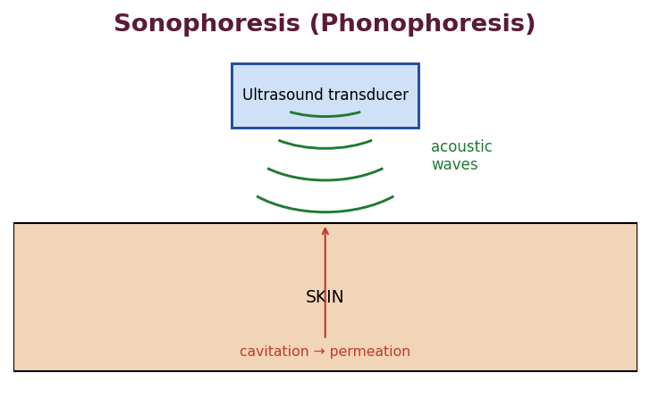
Fig. 24 : Sonophoresis – ultrasound-assisted transdermal delivery
5.4 Formulation Design & Types of Transdermal Patches
A transdermal patch consists of the following components : the backing membrane (occlusive, protects from the environment), the drug reservoir or matrix, the rate-controlling membrane (in reservoir types), the pressure-sensitive adhesive that attaches the patch to the skin, and the release liner (removed before use).
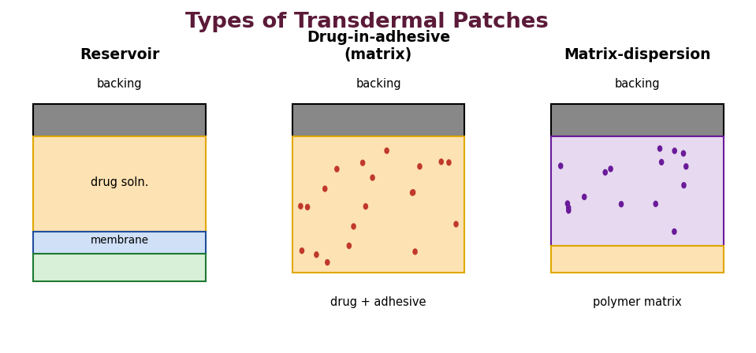
Fig. 25 : Reservoir, drug-in-adhesive and matrix-dispersion transdermal patches
Types
➢ Reservoir (membrane-controlled) system : drug solution / gel held between the backing and a rate-controlling polymeric membrane; gives zero-order release but risk of dose dumping on membrane rupture.
➢ Matrix / monolithic system : drug dispersed in a polymer matrix; the matrix itself controls release (Higuchi kinetics).
➢ Drug-in-adhesive system : drug incorporated directly in the adhesive layer – thin, comfortable, single-layer; the commonest modern design.
➢ Micro-reservoir system : hybrid combining reservoir and matrix principles – tiny drug reservoirs dispersed in a polymer matrix.
5.5 Formulation Considerations & Optimization
Drug selection criteria for TDDS
➢ Molecular weight preferably < 500 Da.
➢ Adequate lipophilicity : log P about 1–3 (balanced partitioning).
➢ Low melting point (< 200 °C) and moderate solubility in both oil and water.
➢ Potent drug – effective daily dose low (ideally < 10–20 mg).
➢ Short biological half-life and non-irritant, non-sensitising to skin.
Optimization of the formulation
The formulation is optimised (often using factorial / response-surface design of experiments) with respect to the type and amount of polymer, plasticiser, penetration enhancer and adhesive, so as to obtain the target flux, adequate adhesion and skin compatibility. In-vitro permeation studies through excised skin or synthetic membranes in Franz diffusion cells are used to measure flux, permeability coefficient and lag time, and to establish an in-vitro / in-vivo correlation.
5.6 Evaluation of Transdermal Systems
➢ Physical : thickness, weight uniformity, folding endurance, moisture content / uptake, tensile strength.
➢ Adhesion tests : peel adhesion, tack and shear strength.
➢ Drug content & content uniformity.
➢ In-vitro release & permeation : Franz diffusion cell across skin / membrane; flux, permeability, lag time.
➢ Skin irritation / sensitisation studies.
➢ Stability studies as per ICH.
5.7 Latest Developments & Applications
Recent advances include microneedle patches (solid, coated, dissolving and hollow), 'smart' feedback-controlled iontophoretic patches, needle-free delivery of vaccines and biologics, and transdermal delivery of peptides / proteins using low-frequency sonophoresis. Marketed TDDS include nitroglycerin, nicotine, fentanyl, clonidine, scopolamine, estradiol, testosterone and rivastigmine patches.

5.8 Detailed Skin Anatomy relevant to Permeation
A sound knowledge of skin structure explains why transdermal delivery is so restricted. The skin is the largest organ (~1.8 m², ~10 % of body weight) and comprises three regions.
Epidermis
The avascular epidermis (50–100 µm) is a stratified epithelium. Its innermost basal layer continuously produces keratinocytes that migrate outward, differentiate and die, forming the stratum corneum. The stratum corneum (10–20 µm, ~15–20 layers of flattened corneocytes) is the principal rate-limiting barrier – a 'brick-and-mortar' arrangement of keratin-rich cells in a matrix of ordered intercellular lipids (ceramides, cholesterol, free fatty acids).
Dermis
The dermis (3–5 mm) is vascular connective tissue containing collagen, elastin, blood and lymph vessels, nerves and the skin appendages (hair follicles, sebaceous and sweat glands). The rich capillary network here carries the permeated drug into the systemic circulation, so the dermis usually offers little resistance to lipophilic drugs but can be a barrier to very lipophilic molecules.
Subcutaneous tissue (hypodermis)
A layer of fat and connective tissue that anchors the skin and acts as a depot for highly lipophilic drugs.
5.9 Factors influencing Transdermal Permeation
Biological factors
➢ Skin condition : damaged / diseased skin (eczema, burns) is far more permeable; solvents and vesicants damage the barrier.
➢ Skin age : infant and elderly skin differ in permeability.
➢ Regional variation : permeability varies with body site (postauricular, scrotal and forehead skin are more permeable than the forearm).
➢ Skin hydration : hydration (occlusion) swells the corneocytes and increases permeation.
➢ Skin temperature & blood flow : higher temperature and blood flow enhance flux.
➢ Skin metabolism : cutaneous enzymes can metabolise the drug (relevant to prodrugs).
Physicochemical factors
➢ Partition coefficient : a balanced log P (~1–3) is optimum; too hydrophilic cannot cross lipid, too lipophilic cannot leave the stratum corneum into the aqueous dermis.
➢ Molecular size : flux falls sharply above ~500 Da.
➢ Solubility & melting point : low melting point correlates with higher solubility and flux.
➢ Degree of ionisation : the unionised form permeates far better; hence pH of the vehicle matters.
➢ Drug concentration & thermodynamic activity : flux is proportional to the thermodynamic activity; supersaturated systems enhance delivery.
5.10 Permeation Mathematics (Michaels / steady state)
For a drug permeating a membrane of thickness h under sink conditions, the amount permeated per unit area (Q) versus time is initially curved and becomes linear at steady state :
Q = (D·Cs / h) × [ t – (h² / 6D) ]
The slope of the linear portion gives the steady-state flux Jss = D·Cs/h and the intercept on the time-axis gives the lag time tₗ = h²/6D, from which the diffusion coefficient D can be estimated. The permeability coefficient is P = Jss / Cv (Cv = donor concentration).
5.11 Microneedle Technology
Microneedles are arrays of micron-scale projections that pierce only the stratum corneum, creating micro-conduits for drug (including macromolecules and vaccines) without reaching the pain nerves or blood vessels of the deeper dermis – hence painless. Four types are recognised :
➢ Solid microneedles : 'poke-and-patch' – pierce the skin, then apply a drug patch/formulation.
➢ Coated microneedles : drug coated on the needle dissolves after insertion.
➢ Dissolving microneedles : made of soluble polymer / sugar containing the drug; dissolve completely, leaving no sharps waste.
➢ Hollow microneedles : permit active infusion of liquid formulation.
5.12 Methods of Preparation of Transdermal Patches
➢ Solvent-casting (film-casting) : polymer, drug, plasticiser and enhancer dissolved in a volatile solvent, cast on a backing and dried – the commonest matrix method.
➢ Hot-melt extrusion : drug and thermoplastic polymer melted and extruded into a film (solvent-free).
➢ Asymmetric-membrane / phase-inversion methods.
5.13 Representative Marketed Transdermal Products
Drug | Indication
Nitroglycerin | Angina prophylaxis
Nicotine | Smoking cessation
Fentanyl | Chronic pain
Scopolamine (hyoscine) | Motion sickness
Clonidine | Hypertension
Estradiol / testosterone | Hormone replacement
Rivastigmine | Alzheimer's dementia
Rotigotine | Parkinson's disease

★ High-yield – TDDS
• Stratum corneum = rate-limiting barrier; intercellular lipid route predominates.
• Ideal drug : MW < 500, log P 1–3, potent (< ~20 mg/day), low melting point, non-irritant.
• Iontophoresis drives charged drugs by current; sonophoresis uses ultrasound cavitation.
• Scopolamine (postauricular) was the first marketed transdermal patch (1979).

5.14 Vesicular Carriers for Skin Delivery (latest developments)
Vesicular systems are among the most important recent developments in skin delivery. They can entrap both hydrophilic and lipophilic drugs, act as a local depot in the skin, and (for the deformable types) enhance penetration through the stratum corneum.
➢ Liposomes : concentric phospholipid bilayer vesicles; localise drug in the upper skin layers and reduce systemic side effects, but classical liposomes penetrate the stratum corneum poorly.
➢ Transfersomes : ultra-deformable ('elastic') liposomes containing an edge activator (surfactant) that lets them squeeze through the intercellular lipid channels along the trans-epidermal hydration gradient – capable of delivering even macromolecules.
➢ Ethosomes : vesicles with a high ethanol content; the ethanol fluidises both the vesicle and the stratum-corneum lipids, giving deep penetration.
➢ Niosomes : non-ionic surfactant vesicles – cheaper and more stable than liposomes.
➢ Pharmacosomes / aquasomes : other colloidal carriers explored for skin delivery.
5.15 Mechanisms of Chemical Penetration Enhancement
Chemical enhancers act by one or more of the following mechanisms (the 'lipid-protein-partitioning' or LPP theory) :
➢ Disruption / fluidisation of the intercellular lipid : e.g., oleic acid, terpenes, Azone insert into and disorder the lipid bilayers.
➢ Interaction with keratin (protein) : e.g., DMSO, surfactants alter the keratin conformation, opening the corneocytes.
➢ Increasing drug partitioning / solubility : co-solvents such as propylene glycol and ethanol increase the drug's partitioning into the stratum corneum.
➢ Increasing hydration : water and occlusion swell the tissue and open the structure.
5.16 Iontophoresis – Mechanisms & Factors
Iontophoresis moves drug by two mechanisms : electro-repulsion (like charges repel, so a cationic drug is driven from the anode and an anionic drug from the cathode) and electro-osmosis (bulk solvent flow from anode to cathode carries neutral and large molecules). Delivery is governed by the current density, duration, drug charge and concentration, pH and the electrode system. Because it can be switched on and off and the rate set by the current, iontophoresis allows programmable, feedback-controlled delivery (e.g., the GlucoWatch® reverse-iontophoresis glucose monitor, and fentanyl iontophoretic patches).
5.17 Sonophoresis & Other Physical Methods
Sonophoresis uses ultrasound (low frequency 20–100 kHz is most effective) to enhance permeation, chiefly through cavitation – the formation and violent collapse of gas bubbles that transiently disorganise the stratum-corneum lipids. It can deliver macromolecules such as insulin and heparin. Related physical methods include electroporation (high-voltage pulses forming transient pores), thermal ablation, laser microporation and needle-free jet injection.
5.18 Ideal Properties & Components – Consolidated
Component | Function | Example
Backing membrane | Occlusive protective outer layer | Polyester, aluminised film
Drug reservoir / matrix | Holds the drug | Silicone, acrylate, HPMC
Rate-controlling membrane | Controls release (reservoir type) | EVA
Pressure-sensitive adhesive | Attaches patch to skin | Polyacrylate, silicone
Release liner | Protects adhesive; removed before use | Siliconised polyester

Unit VI – Personalized Medicine
6.1 Introduction & Definition
The traditional 'one-size-fits-all' approach to drug therapy assumes that a given dose of a given drug will produce a similar response in all patients. In reality, patients differ widely in their response owing to genetic, physiological, environmental and lifestyle differences, so that the same drug may be ineffective in some and toxic in others. Personalized (individualised / precision) medicine seeks to tailor the choice of drug, the dose and the delivery to the characteristics of the individual patient.
Definition : Personalized medicine is a medical model that uses an individual's genetic, molecular, biomarker and clinical information to tailor prevention, diagnosis and treatment – delivering the right drug, at the right dose, to the right patient, at the right time.
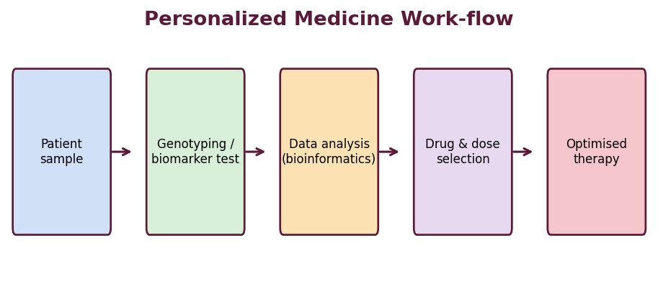
Fig. 26 : Work-flow of personalized medicine
Aims / advantages
➢ Maximise efficacy while minimising adverse drug reactions.
➢ Select responders and avoid treating non-responders (companion diagnostics).
➢ Individualise the dose to the patient's metabolic capacity.
➢ Enable early / predictive and preventive intervention.
➢ Reduce trial-and-error prescribing and overall cost of therapy.
6.2 Pharmacogenetics & Pharmacogenomics
Pharmacogenetics is the study of how variations in a single gene influence an individual's response to a drug, whereas pharmacogenomics is the broader study of how the entire genome (many genes) affects drug response. Both form the scientific basis of personalized medicine.
Genetic polymorphisms may affect pharmacokinetics (drug-metabolising enzymes, transporters) or pharmacodynamics (receptors, targets). The most important examples involve the cytochrome-P450 enzymes.
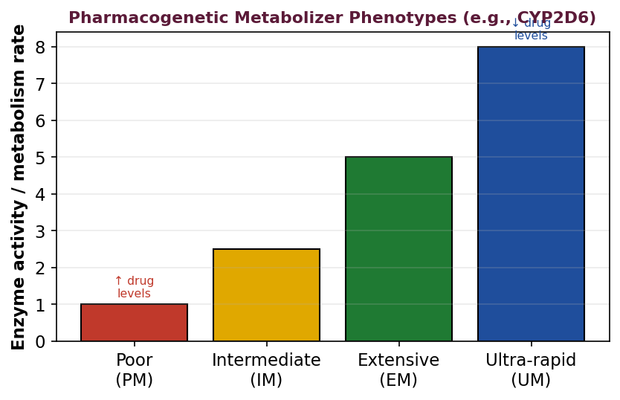
Fig. 27 : Pharmacogenetic metabolizer phenotypes (illustrated for CYP2D6)
Metabolizer phenotypes
➢ Poor metabolizers (PM) : deficient enzyme activity – drug accumulates; risk of toxicity at standard doses (or failure to activate a prodrug).
➢ Intermediate metabolizers (IM) : reduced activity.
➢ Extensive metabolizers (EM) : normal 'wild-type' activity.
➢ Ultra-rapid metabolizers (UM) : increased activity – drug cleared too fast; therapeutic failure, or excessive activation of a prodrug.
Clinical pharmacogenetic examples
Gene / marker | Drug | Clinical relevance
CYP2C9 / VKORC1 | Warfarin | Dose individualisation to avoid bleeding
CYP2D6 | Codeine, tamoxifen | PM – no analgesia; UM – toxicity
TPMT | Azathioprine / 6-MP | Low activity → severe myelosuppression
HLA-B*57:01 | Abacavir | Hypersensitivity reaction – test before use
HER2 (Neu) | Trastuzumab | Only HER2-positive breast cancers respond
EGFR mutation | Gefitinib / erlotinib | Predicts response in NSCLC
UGT1A1 | Irinotecan | Reduced activity → toxicity

6.3 Categories of Patients for Personalized Medicine
Personalized approaches are especially valuable for the following categories of patients, in whom variability or special needs make standard therapy risky or sub-optimal :
➢ Patients on drugs with a narrow therapeutic index (e.g., warfarin, digoxin, immunosuppressants).
➢ Patients with known genetic polymorphisms in metabolising enzymes / targets.
➢ Cancer patients (tumour molecular profiling guides targeted therapy).
➢ Paediatric and geriatric patients (special dose and formulation needs).
➢ Patients with organ (hepatic / renal) impairment altering pharmacokinetics.
➢ Patients showing unusual response – non-responders or those with adverse reactions.
➢ Patients requiring complex multi-drug regimens (polypharmacy).
6.4 Customized Drug Delivery Systems
Once the individual requirement is known, the delivery system itself can be customised – in dose, combination, release profile, size and shape – to suit the patient. Approaches include :
➢ Individualised dosing : compounding or printing the exact dose required for a specific patient rather than commercial fixed strengths.
➢ Polypills / fixed-dose combinations : multiple drugs a patient needs combined in one unit to improve adherence.
➢ Tailored release profiles : chronotherapeutic or multi-phasic release matched to the patient's disease rhythm.
➢ Patient-friendly forms : orodispersible, chewable or flavoured forms for children and the elderly.
➢ Point-of-care / on-demand manufacture : small-scale production (e.g., 3D printing) at the pharmacy or hospital.
6.5 Bioelectronic Medicines
Bioelectronic medicine (electroceuticals) is an emerging field that uses electrical impulses delivered by miniature implanted devices to modulate the activity of nerves and organs, instead of (or in addition to) chemical drugs. By reading and correcting the electrical signalling of the body's neural circuits, these devices aim to treat disease with high precision and few systemic side effects.
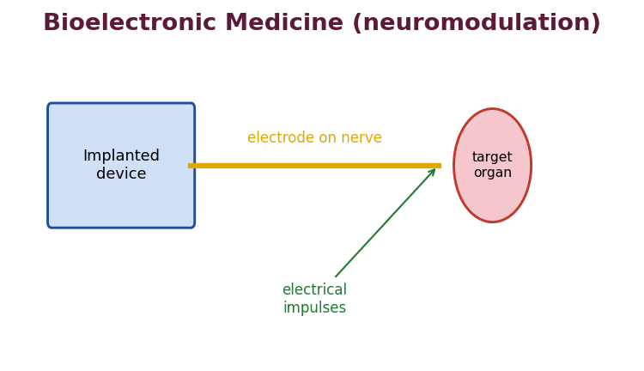
Fig. 28 : Principle of a bioelectronic (neuromodulation) device
Examples & applications
➢ Cardiac pacemakers and implantable cardioverter-defibrillators.
➢ Deep-brain stimulation for Parkinson's disease and essential tremor.
➢ Vagus-nerve stimulation for epilepsy, depression and inflammatory disease.
➢ Spinal-cord stimulators for chronic pain.
➢ Cochlear implants; sacral-nerve stimulation for bladder control.
Advantages : highly targeted, drug-free, reversible and adjustable. Limitations : invasive implantation, device / battery maintenance and high cost.
6.6 3D Printing of Pharmaceuticals
Three-dimensional (3D) printing is an additive manufacturing technique that builds a solid object layer-by-layer from a digital design. Applied to pharmaceuticals, it allows on-demand fabrication of dosage forms with a precisely controlled dose, geometry, internal structure and release profile – a powerful enabler of personalized medicine.
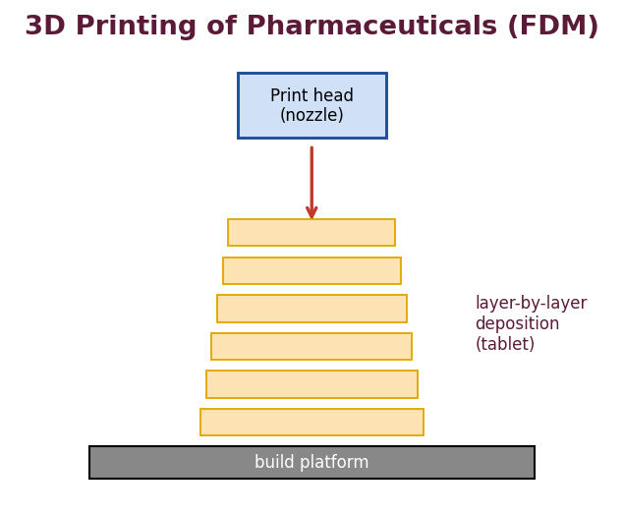
Fig. 29 : Fused-deposition-modelling 3D printing of a tablet
Common 3D-printing techniques for medicines
➢ Fused deposition modelling (FDM) : a drug-loaded polymer filament is melted and extruded layer-by-layer.
➢ Powder-based binder-jet printing : a liquid binder is jetted onto powder layers (used for Spritam®, the first FDA-approved 3D-printed tablet, a rapidly-disintegrating levetiracetam form).
➢ Stereolithography (SLA) : a photopolymer resin is cured by light layer-by-layer – high resolution.
➢ Semi-solid extrusion (SSE) : a paste / gel is extruded – suitable at room temperature for heat-labile drugs.
Advantages of 3D-printed medicines
➢ Precise, flexible and individualised dosing (any strength).
➢ Complex geometries and multi-drug 'polyprintlets' with tailored release.
➢ Rapid prototyping and on-demand, decentralised manufacture.
➢ Reduction of excipients and possibility of highly porous, fast-dissolving tablets.
Challenges include regulatory approval, quality control of small batches, limited range of pharmaceutical-grade printable materials and stability during processing.
6.7 Telepharmacy
Telepharmacy is the delivery of pharmaceutical care and services by a registered pharmacist to patients at a distance through the use of telecommunications and information technology, when direct, in-person contact is not possible. It extends pharmacy services to remote, rural and under-served areas.
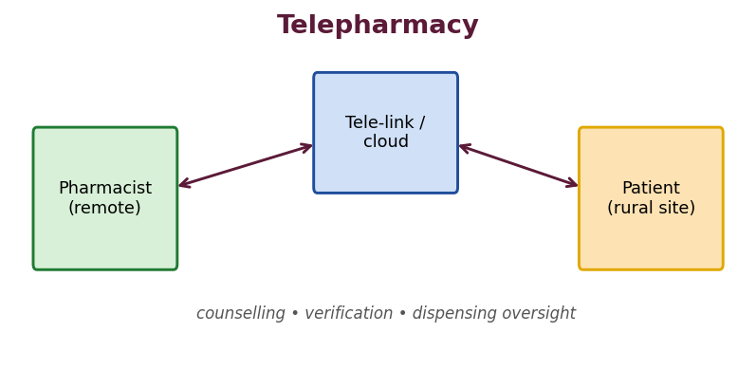
Fig. 30 : Telepharmacy – remote delivery of pharmaceutical care
Services & applications
➢ Remote order entry, prescription review and verification by a pharmacist.
➢ Tele-counselling and patient education via video link.
➢ Remote supervision of dispensing at a satellite / automated site.
➢ Medication-therapy management and monitoring of chronic patients.
➢ Support for rural hospitals lacking an on-site pharmacist.
Advantages : improved access, cost savings, expanded reach and continuity of care. Limitations : dependence on technology / connectivity, data-privacy and security concerns, licensing / regulatory issues and the absence of physical examination.

6.8 The Human Genome, SNPs & the Basis of Variability
The completion of the Human Genome Project (2003) provided the reference against which individual variation is measured. The most common form of genetic variation is the single-nucleotide polymorphism (SNP) – a single base difference occurring in at least 1 % of the population. SNPs (and copy-number variations) in genes coding for drug-metabolising enzymes, transporters, receptors and targets account for much of the inter-individual difference in drug response, and are the molecular foundation of pharmacogenomics.
6.9 Biomarkers & Companion Diagnostics
A biomarker is a measurable indicator of a biological state (a gene, protein, metabolite or imaging feature) used to predict disease, prognosis or drug response. A companion diagnostic is an in-vitro test that is co-developed with a drug and is essential for its safe and effective use – it identifies the patients most likely to benefit (or to be harmed). Examples : HER2 testing before trastuzumab; EGFR mutation testing before gefitinib; BRAF V600E testing before vemurafenib; KRAS testing before cetuximab.
6.10 Pharmacogenomics in Oncology (Targeted Therapy)
Cancer is the flagship application of personalized medicine because tumours can be molecularly profiled and matched to targeted drugs. Genotyping the tumour identifies 'driver' mutations that can be blocked selectively, sparing normal cells and reducing toxicity compared with conventional cytotoxic chemotherapy.
Tumour marker | Targeted drug | Cancer
HER2 amplification | Trastuzumab | Breast
BCR-ABL fusion | Imatinib | Chronic myeloid leukaemia
EGFR mutation | Gefitinib / erlotinib | Non-small-cell lung
BRAF V600E | Vemurafenib | Melanoma
KRAS wild-type | Cetuximab | Colorectal
PD-L1 expression | Pembrolizumab | Various (immunotherapy)

6.11 Nanotechnology in Personalized Medicine
Nanocarriers (liposomes, polymeric nanoparticles, dendrimers, micelles) can be engineered with targeting ligands (antibodies, peptides, folate) that recognise markers over-expressed on a particular patient's diseased cells, giving 'theranostic' systems that combine therapy and diagnosis. This allows the delivery to be personalised to the molecular signature of the individual's disease.
6.12 Advances in Customized Manufacturing
Beyond 3D printing, personalized dosage forms are enabled by : automated compounding, printed orodispersible films of individualised dose, and digital 'formulation-on-demand'. 3D printing in particular allows dose flexibility, complex multi-drug 'polyprintlets', tailored release geometry and rapid decentralised production at the point of care.
Comparison of 3D-printing techniques
Technique | Principle | Note
FDM | Melt-extrude drug-loaded filament | Needs thermostable drug
Binder-jet | Liquid binder on powder bed | Spritam® (levetiracetam)
SLA | Light-cures liquid resin | High resolution
SSE | Extrudes paste at room temp | Good for heat-labile drugs

6.13 Challenges, Ethics & Future Perspective
➢ Scientific : many diseases are polygenic and multifactorial; a single marker rarely explains response fully.
➢ Economic : cost of genotyping and companion diagnostics; reimbursement issues.
➢ Ethical & legal : genetic privacy, informed consent, risk of discrimination, data security.
➢ Regulatory : approval frameworks for small / individualised batches (e.g., 3D-printed medicines) and companion diagnostics.
➢ Educational : need to train clinicians and pharmacists in genomics.
★ High-yield – Personalized Medicine
• Right drug – right dose – right patient – right time.
• Pharmacogenetics = one gene; pharmacogenomics = whole genome; SNP = commonest variation.
• Companion diagnostics : HER2–trastuzumab, EGFR–gefitinib, HLA-B*57:01–abacavir, TPMT–azathioprine.
• Spritam® = first FDA-approved 3D-printed tablet (binder-jet).
• Electroceuticals = bioelectronic medicine; telepharmacy extends care to remote areas.

6.14 Evolution & Levels of Personalized Medicine
The idea that treatment should suit the individual is ancient, but modern personalized medicine became feasible only with the molecular-biology revolution and the sequencing of the human genome. It can be applied at several levels : selecting the drug (responder identification), individualising the dose (to metabolic capacity), timing the therapy (chronotherapy), and tailoring the delivery system (customised dosage form). The greater the genetic and physiological contribution to variability, the greater the benefit of a personalized approach.
6.15 Pharmacokinetic vs Pharmacodynamic Pharmacogenetics
Genetic variation influences drug response through two routes :
➢ Pharmacokinetic (PK) polymorphisms : affect drug-metabolising enzymes (CYP2D6, CYP2C9, CYP2C19, TPMT, UGT1A1, NAT2) and transporters (P-glycoprotein), changing the drug's concentration.
➢ Pharmacodynamic (PD) polymorphisms : affect the drug target or pathway (receptors, VKORC1 for warfarin, β-adrenoceptors, ion channels), changing the response at a given concentration.
6.16 Applications across Specialties
Specialty | Personalized example
Cardiology | Warfarin & clopidogrel (CYP2C19) dosing
Oncology | HER2, EGFR, BRAF-guided targeted therapy
Psychiatry | CYP2D6 / CYP2C19 dosing of antidepressants
Infectious disease | HLA-B*57:01 before abacavir; HCV genotype-guided therapy
Transplant / immunology | TPMT before thiopurines
Pain | CYP2D6 status and codeine efficacy / toxicity

6.17 Digital Health, Wearables & Artificial Intelligence
Personalized medicine is increasingly supported by digital tools. Wearable sensors and 'digital pills' (ingestible sensors) provide continuous, individual physiological and adherence data. Electronic health records combined with machine-learning / artificial-intelligence algorithms can integrate genomic, clinical and lifestyle data to predict the best therapy for a given patient and to support clinical decisions. These technologies also underpin telepharmacy and remote monitoring.
6.18 Gene & Cell Therapy – the Ultimate Personalization
Gene therapy (introducing, correcting or silencing a gene) and cell therapies such as CAR-T (a patient's own T-cells engineered to attack their cancer) represent the most individualised treatments of all, being manufactured for a single patient. Although outside the scope of routine formulation, they illustrate the direction in which personalized medicine is moving, and depend heavily on advanced, targeted delivery systems (viral and non-viral vectors, lipid nanoparticles).
6.19 Bioelectronic Medicine – Further Detail
Bioelectronic devices work by recording and/or stimulating the electrical activity of specific neural circuits. By closing the loop – sensing a physiological signal and delivering a corrective electrical stimulus – they can regulate organ function with a precision and reversibility that chemical drugs cannot match. Current research targets include the vagus nerve (inflammation, rheumatoid arthritis, diabetes) and peripheral nerves controlling metabolism and immunity. Advantages are high specificity and freedom from systemic drug side effects; challenges are the invasiveness of implantation, power supply, biocompatibility of electrodes and long-term stability.
6.20 Telepharmacy – Models & Regulation
Telepharmacy is implemented through several models : remote dispensing sites supervised by a central pharmacist; tele-consultation and counselling; remote order verification for hospitals; and automated dispensing units with video oversight. Its practice requires appropriate licensing, standard operating procedures, secure data-transfer that protects patient confidentiality, and validated technology. When well governed, it extends the reach of the pharmacist and improves access to medicines and pharmaceutical care in remote and under-served communities.

Selection of Drugs & Polymers for Delivery Systems
A.1 Why Polymers are Central to Advanced DDS
Polymers are the workhorses of novel drug delivery. They form the membranes, matrices, coats and scaffolds that control the rate, time and place of drug release. The choice of polymer determines whether the release is diffusion-, dissolution-, osmotic- or erosion-controlled, and whether the device is biodegradable or must be removed. This section consolidates the polymer knowledge required across all units.
A.2 Criteria for Selection of a Drug for a Novel DDS
The general criteria (detailed in Units I and V) are summarised : appropriate molecular size and solubility, suitable partition coefficient, an intermediate biological half-life, low effective dose, good stability, adequate therapeutic index and uniform absorption. The specific requirement varies with the system (e.g., high potency for TDDS and implants; ionisable for ion-exchange systems and iontophoresis).
A.3 Criteria for Selection of a Polymer
➢ Biocompatible, non-toxic, non-immunogenic and non-carcinogenic.
➢ Chemically compatible and non-reactive with the drug.
➢ Able to provide the desired release rate and mechanical properties.
➢ Easily processed and sterilisable; stable on storage.
➢ For biodegradable systems : predictable, controllable degradation to safe products.
➢ Economical and readily available in pharmaceutical grade.
A.4 Classification of Polymers used in DDS
(a) Natural polymers
Gelatin, gum acacia, sodium alginate, chitosan, starch, albumin, zein, guar gum, xanthan gum, cellulose. Generally biocompatible and biodegradable, but batch variability and microbial contamination are concerns.
(b) Synthetic non-biodegradable polymers
Silicone (polydimethylsiloxane, PDMS), ethylene-vinyl acetate (EVA), polyurethane, poly(methyl methacrylate), ethylcellulose, polyethylene. Used for reservoir membranes and non-degradable implants that must be removed.
(c) Synthetic biodegradable polymers
Poly(lactic acid) (PLA), poly(glycolic acid) (PGA), poly(lactic-co-glycolic acid) (PLGA), poly-ε-caprolactone (PCL), polyanhydrides and poly-ortho-esters. Erode in the body to safe metabolites and need no removal – the mainstay of injectable depots and implants.
(d) pH-dependent (enteric) & other functional polymers
Cellulose acetate phthalate, hydroxypropylmethylcellulose phthalate, shellac and the methacrylic-acid copolymers (Eudragit® L, S, RS, RL) provide site-specific (enteric / colonic) release and film coating.
Rate-control mechanism | Representative polymers
Diffusion (reservoir membrane) | Silicone, EVA, ethylcellulose
Diffusion / swelling matrix | HPMC, carbopol, sodium alginate
Dissolution / erosion | Waxes, PLGA, polyanhydrides
Osmotic | Cellulose acetate (semipermeable membrane)
Ion-exchange | Polacrilin (cross-linked polymethacrylate resins)
Mucoadhesion | Carbopol, chitosan, Na-CMC, thiomers
Enteric / site specific | CAP, HPMCP, Eudragit L/S, shellac

Monographs of Important DDS Polymers
A working knowledge of the individual polymers used in advanced delivery is essential for the rational selection required by this course. The following short monographs summarise the nature, mechanism and typical use of the most important polymers.
P.1 Hydroxypropyl Methylcellulose (HPMC / Hypromellose)
A non-ionic, water-soluble cellulose ether available in many viscosity grades. On hydration it forms a viscous gel layer that controls release, making it the workhorse of hydrophilic matrix tablets. It is also used as a film-coating agent and binder. Release rate is tuned by viscosity grade and polymer level. Non-toxic, widely accepted and inexpensive.
P.2 Ethylcellulose
A water-insoluble, non-ionic cellulose ether used as a rate-controlling membrane coat and as an insoluble matrix former for diffusion-controlled release. Combined with a pore-former (HPMC, PEG) its permeability can be adjusted. Also used for microencapsulation and taste masking.
P.3 Methacrylic-acid Copolymers (Eudragit®)
A family of acrylic / methacrylic copolymers with different functional groups :
➢ Eudragit L / S : anionic, dissolve above pH 6 / 7 – enteric and colonic (site-specific) release.
➢ Eudragit RL / RS : contain quaternary ammonium groups; insoluble but permeable – sustained release (RL more permeable than RS).
➢ Eudragit E : cationic, soluble in gastric fluid – taste masking / protective coats.
P.4 Poly(lactic-co-glycolic acid) (PLGA)
The most widely used synthetic biodegradable polymer for microspheres, implants and in-situ depots. It undergoes bulk hydrolysis to lactic and glycolic acids, which are eliminated through normal metabolism. Degradation time (weeks to months) is tuned by the lactide : glycolide ratio and molecular weight; a higher glycolide fraction degrades faster. Requires no removal.
P.5 Silicone (Polydimethylsiloxane, PDMS)
A biocompatible, non-biodegradable elastomer used as a rate-controlling membrane and matrix in reservoir implants and inserts (Norplant, vaginal rings, Ocusert). Lipophilic drugs partition and diffuse through it, giving near zero-order release. Chemically inert and stable, but must be surgically removed.
P.6 Ethylene-Vinyl Acetate (EVA)
A flexible, biocompatible, non-degradable copolymer whose permeability increases with vinyl-acetate content. Used as the rate-controlling membrane of the Ocusert insert, of implants and of vaginal rings.
P.7 Chitosan
A natural cationic polysaccharide obtained by deacetylation of chitin. Biodegradable, biocompatible, mucoadhesive and permeation-enhancing. Used in mucoadhesive systems, nasal / colon delivery, nanoparticles and ionotropic-gelation microspheres (cross-linked with tripolyphosphate).
P.8 Carbopol (Polyacrylic acid)
A high-molecular-weight, cross-linked polyacrylic-acid polymer that swells to a gel in water. An excellent mucoadhesive and a rate-controlling agent in matrices and gels; widely used in buccal, ocular and gastro-retentive systems.
P.9 Sodium Alginate
A natural anionic polysaccharide from seaweed that forms gel beads instantly on contact with divalent calcium ions (ionotropic gelation) – a mild, aqueous route to microspheres suitable for proteins. Also used in raft-forming and mucoadhesive systems.
P.10 Cellulose Acetate
A water-insoluble polymer used chiefly as the semipermeable membrane of osmotic pumps, permitting water influx while remaining impermeable to solutes. Its permeability is adjusted with plasticisers and pore-formers.
Summary table
Polymer | Nature | Principal DDS use
HPMC | Soluble, non-ionic | Hydrophilic matrix / coating
Ethylcellulose | Insoluble, non-ionic | Membrane / insoluble matrix
Eudragit L/S | Anionic, pH-sensitive | Enteric / colonic release
Eudragit RL/RS | Insoluble, permeable | Sustained release
PLGA | Biodegradable polyester | Microspheres / implants
Silicone (PDMS) | Inert elastomer | Reservoir implants / rings
EVA | Non-degradable | Rate-controlling membrane
Chitosan | Cationic natural | Mucoadhesive / nanoparticles
Carbopol | Cross-linked acrylic | Mucoadhesion / gel matrix
Cellulose acetate | Semipermeable | Osmotic-pump membrane

Formulation Design & Optimization
O.1 The Need for Systematic Optimization
The performance of an advanced delivery system depends on several interacting formulation and process variables (polymer type and level, plasticiser, enhancer, coating thickness, process parameters). Changing one factor at a time (OFAT) is slow, misses interactions and rarely finds the true optimum. A statistical Design of Experiments (DoE) approach studies all factors simultaneously, reveals interactions and locates the optimum with the fewest experiments – the basis of the modern Quality-by-Design (QbD) philosophy.
O.2 Terminology
➢ Factor : an independent variable that is changed (e.g., polymer amount).
➢ Level : the value assigned to a factor (low / high, coded − / +).
➢ Response : the measured output (e.g., % released at a given time, flux).
➢ Interaction : when the effect of one factor depends on the level of another.
➢ Design space : the multidimensional combination of factors shown to assure quality.
O.3 Factorial Designs
In a full factorial design, every combination of factor levels is studied. A two-level, three-factor design (2³) needs 8 experiments and estimates all main effects and interactions. When the number of factors is large, fractional factorial and Plackett–Burman designs are used for screening the important factors with fewer runs.
O.4 Response-Surface Methodology (RSM)
Once the important factors are identified, RSM designs (central-composite, Box–Behnken) fit a second-order (quadratic) model that describes curvature and locates the optimum. The results are visualised as contour and 3-D response-surface plots, from which the factor settings giving the target release profile are chosen and validated.
O.5 Quality by Design (QbD) & Process Analytical Technology
QbD (ICH Q8) builds quality into the product by design rather than testing it in at the end. It begins with the Quality Target Product Profile (QTPP), identifies the Critical Quality Attributes (CQAs) such as the release profile, links them to Critical Material Attributes and Critical Process Parameters through risk assessment and DoE, and defines a design space and a control strategy. Process Analytical Technology (PAT) provides real-time monitoring to keep the process within that space.
★ High-yield – Optimization
• OFAT ignores interactions; factorial designs study all factors together.
• 2³ full factorial = 8 runs; RSM (CCD / Box–Behnken) locates the optimum.
• QbD (ICH Q8) : QTPP → CQA → design space → control strategy.

Evaluation Methods for Advanced DDS
E.1 In-Vitro Dissolution / Release Testing
Dissolution testing is the single most important in-vitro tool for characterising modified-release products and for quality control. It measures the rate and extent of drug release under standardised conditions and, when correlated with in-vivo data (IVIVC), can serve as a surrogate for bioequivalence.
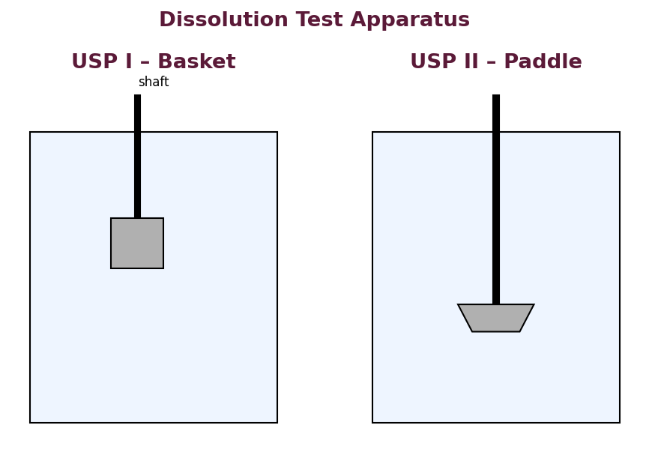
Fig. 31 : USP dissolution apparatus I (basket) and II (paddle)
USP dissolution apparatus
Apparatus | Type | Typical use
I | Rotating basket | Capsules, floating / disintegrating forms
II | Paddle | Tablets (most common)
III | Reciprocating cylinder | Modified-release, pH change studies
IV | Flow-through cell | Poorly soluble drugs, implants, suppositories
V | Paddle over disc | Transdermal patches
VI | Rotating cylinder | Transdermal patches
VII | Reciprocating holder | Small-volume, transdermal, stents

Key variables to be controlled and reported are the medium (volume, pH, surfactant), temperature (37 ± 0.5 °C), rotation speed and sampling times. The medium is chosen to provide sink conditions and to reflect the physiological environment; a pH change (e.g., 1.2 → 6.8) may be programmed for enteric and colonic systems.
Comparison of dissolution profiles
Two release profiles are compared using model-independent factors :
➢ Difference factor f₁ : measures the percentage difference between two curves; f₁ should be 0–15 for similarity.
➢ Similarity factor f₂ : a logarithmic transformation of the mean squared difference; f₂ between 50 and 100 indicates similar profiles.
f₂ = 50 × log { [1 + (1/n)Σ(Rₜ – Tₜ)²]^(–0.5) × 100 }
E.2 In-Vitro Permeation Testing (TDDS)
Skin permeation is studied in a Franz diffusion cell : the skin (or a synthetic membrane) is mounted between a donor compartment (holding the patch / formulation) and a receptor compartment (holding the receptor medium, stirred and thermostatted at 32–37 °C). Samples are withdrawn from the receptor at intervals and assayed; the cumulative amount permeated per unit area is plotted against time to obtain the steady-state flux (Jss), permeability coefficient and lag time.
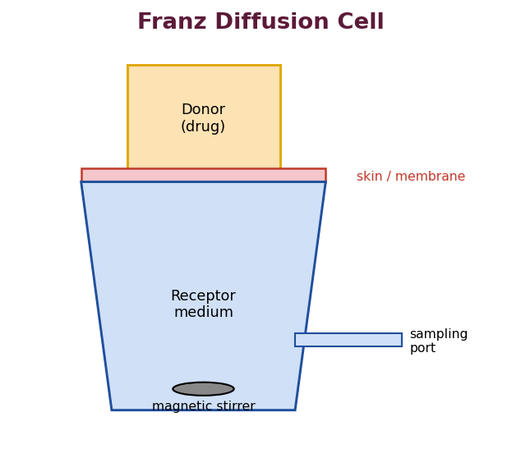
Fig. 32 : Franz diffusion cell for in-vitro skin permeation studies
E.3 Solid-State & Physical Characterisation
➢ Particle size & morphology : optical / electron microscopy (SEM), laser diffraction, sieving.
➢ Thermal analysis : DSC and TGA detect polymorphism, drug–polymer interaction and thermal events.
➢ X-ray powder diffraction (XRPD) : distinguishes crystalline and amorphous states.
➢ FTIR / spectroscopy : confirms drug–excipient compatibility.
➢ Mechanical tests : hardness, friability, tensile strength, folding endurance (films).
E.4 Biopharmaceutics Classification System (BCS)
The BCS classifies drugs by aqueous solubility and intestinal permeability into four classes; it guides formulation strategy and underpins the biowaiver of in-vivo bioequivalence studies for certain immediate-release products.
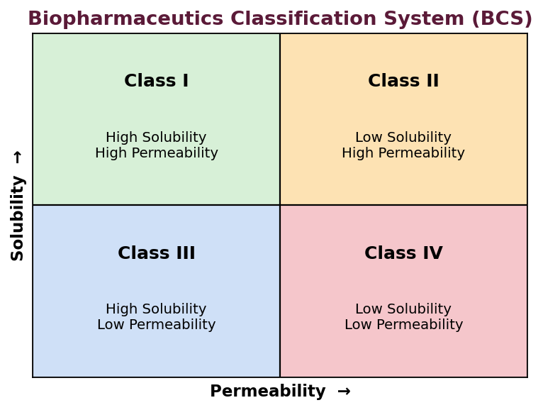
Fig. 33 : Biopharmaceutics Classification System (BCS)
➢ Class I (high solubility, high permeability) : well absorbed; dissolution usually not limiting.
➢ Class II (low solubility, high permeability) : dissolution-limited; solubility-enhancement strategies help.
➢ Class III (high solubility, low permeability) : permeation-limited; absorption enhancers / mucoadhesion help.
➢ Class IV (low solubility, low permeability) : poorly absorbed; the most challenging.
E.5 In-Vivo & Bioavailability Studies
Ultimately, the performance of an advanced DDS is confirmed in vivo by measuring the plasma-concentration–time profile and deriving Cmax, Tmax and AUC, and by comparing these with a reference to establish relative bioavailability or bioequivalence. A validated IVIVC then links these to the in-vitro release, allowing release testing to be used for routine control.

Stability & Regulatory Considerations
R.1 Importance of Stability in Advanced DDS
Modified-release and novel delivery systems often contain polymers, plasticisers and functional coats whose properties can change on storage, altering the release profile (for example, film curing / ageing of a coated pellet can slow release over time). Stability studies must therefore verify not only the chemical stability of the drug but also the constancy of the release characteristics throughout the shelf-life.
R.2 Degradation Kinetics & Shelf-life
The rate of chemical degradation follows an order of reaction (zero, first or second). For most drugs, degradation is first-order, and the time for 10 % loss (t₉₀, the shelf-life or expiry period) is calculated from the rate constant. Accelerated studies at elevated temperature, analysed by the Arrhenius equation, allow the room-temperature shelf-life to be predicted.
log k = log A – (Ea / 2.303 R) × (1/T) (Arrhenius)
t₉₀ = 0.105 / k (first-order)
R.3 ICH Stability Testing
The International Council for Harmonisation (ICH) guideline Q1A(R2) prescribes the conditions for stability testing of new drug substances and products :
Study | Condition | Minimum period
Long-term | 25 °C / 60 % RH | 12 months
Intermediate | 30 °C / 65 % RH | 6 months
Accelerated | 40 °C / 75 % RH | 6 months

Related guidelines : Q1B (photostability), Q1C (new dosage forms), Q1D (bracketing and matrixing designs), Q1E (evaluation of stability data). Climatic zones (I–IV) define the storage conditions appropriate to the intended market.
Bracketing & matrixing
➢ Bracketing : only the extremes of certain design factors (e.g., strength, container size) are tested, assuming the intermediates are represented by the extremes.
➢ Matrixing : a selected subset of samples is tested at each time point, reducing the total number of tests.
R.4 Regulatory Aspects of Modified-Release Products
Modified-release products require additional documentation : justification of the release mechanism, in-vitro release specifications with a validated method, IVIVC where possible, food-effect studies, dose-dumping (alcohol-interaction) studies, and demonstration that the release is reproducible across batches. Novel systems such as 3D-printed and individualised medicines pose new regulatory challenges regarding batch definition, quality control of small quantities and point-of-care manufacture, which regulators are actively addressing.
★ High-yield – Stability & Regulatory
• First-order shelf-life t₉₀ = 0.105 / k; Arrhenius predicts long-term from accelerated data.
• ICH long-term = 25 °C/60 % RH; accelerated = 40 °C/75 % RH for 6 months.
• Modified-release products need dose-dumping (alcohol) and food-effect studies.

Numericals & Worked Examples
N.1 Elimination Rate Constant & Half-life
★ Example 1
• A drug has a half-life of 3 h. Calculate its elimination rate constant.
• Solution : kₑ = 0.693 / t½ = 0.693 / 3 = 0.231 h⁻¹.

N.2 Zero-order Release / Maintenance Dose
★ Example 2
• Desired steady-state plasma level Cp = 8 mg/L; Vd = 25 L; t½ = 5 h. Find the zero-order release rate and the maintenance dose for 8 h.
• kₑ : 0.693/5 = 0.1386 h⁻¹.
• Release rate Kᵣ₀ : Cp × kₑ × Vd = 8 × 0.1386 × 25 = 27.7 mg/h.
• Maintenance dose (8 h) : 27.7 × 8 = 221.7 mg.

N.3 Loading Dose & Total Dose
★ Example 3
• For the drug in Example 2 (F = 1), find the loading dose and total dose.
• Loading dose D₀ : Cp × Vd = 8 × 25 = 200 mg.
• Total dose W : D₀ + Dₘ = 200 + 221.7 = 421.7 mg.

N.4 Corrected Loading Dose
★ Example 4
• If the immediate-release portion peaks at Tₚ = 1.5 h and Kᵣ₀ = 27.7 mg/h, find the corrected loading dose.
• D₀(corrected) : D₀ – (Kᵣ₀ × Tₚ) = 200 – (27.7 × 1.5) = 200 – 41.6 = 158.4 mg.

N.5 Bioavailability Correction (oral)
★ Example 5
• A drug with F = 0.8 requires Cp = 10 mg/L and Vd = 20 L. Find the oral loading dose.
• D₀ : (Cp × Vd)/F = (10 × 20)/0.8 = 250 mg.

N.6 Higuchi Release
★ Example 6
• A matrix releases 20 % of its drug in 1 h and follows Higuchi kinetics (Q = kₕ√t). How much is released in 4 h?
• kₕ : Q/√t = 20/√1 = 20 %·h⁻⁰·⁵.
• At 4 h : Q = 20 × √4 = 20 × 2 = 40 %.
• Note : release doubles when time quadruples – characteristic of √t kinetics.

N.7 Permeation – Flux & Lag Time
★ Example 7
• A transdermal patch shows a steady-state flux of 25 µg/cm²/h and a lag time of 2 h across skin 40 µm thick. Estimate the diffusion coefficient.
• From tₗ = h²/6D : D = h²/(6·tₗ).
• Convert h : 40 µm = 40 × 10⁻⁴ cm = 4 × 10⁻³ cm.
• D : (4×10⁻³)² / (6×2) = 1.6×10⁻⁵ / 12 = 1.33 × 10⁻⁶ cm²/h.

N.8 Osmotic Delivery Rate (concept)
★ Example 8
• State how the delivery rate of an elementary osmotic pump changes if the membrane area is doubled (other factors constant).
• Answer : since dM/dt ∝ A, doubling the membrane area doubles the delivery rate.

Therapeutic Applications of Advanced DDS
T.1 Cardiovascular System
Once-daily controlled-release nifedipine (GITS/osmotic), diltiazem and verapamil provide smooth 24-h blood-pressure control and avoid the reflex tachycardia caused by peaks. Transdermal nitroglycerin gives sustained anti-anginal prophylaxis and transdermal clonidine controls hypertension while avoiding first-pass metabolism. Chronotherapeutic (pulsatile) systems time the release of antihypertensives and anti-anginals to the early-morning surge in cardiovascular events.
T.2 Central Nervous System
Extended-release formulations of anti-epileptics and antidepressants reduce dosing frequency and smooth plasma levels. Transdermal rivastigmine improves tolerability in Alzheimer's disease, transdermal rotigotine gives continuous dopaminergic stimulation in Parkinson's disease, and deep-brain stimulation (bioelectronic) treats movement disorders. Personalized dosing guided by CYP2D6 / CYP2C19 genotype improves antidepressant therapy.
T.3 Endocrine & Reproductive System
Long-acting contraceptive implants (Norplant, Implanon), depot injections (Depo-Provera), vaginal rings (NuvaRing) and intra-uterine systems (Mirena) provide months-to-years of reliable, reversible contraception. Insulin delivery is being advanced by pumps, closed-loop 'artificial pancreas' systems and needle-free / sonophoretic approaches.
T.4 Oncology
Biodegradable implants (Gliadel wafer, Zoladex), depot microspheres (Lupron Depot) and targeted nanocarriers deliver chemotherapy with improved local concentration and reduced systemic toxicity. Personalized, biomarker-guided targeted therapy (trastuzumab, imatinib, gefitinib) exemplifies precision oncology.
T.5 Ophthalmology
Ocular inserts (Ocusert), intra-ocular implants (Vitrasert, Retisert) and punctal/mucoadhesive systems overcome the very poor bioavailability of eye drops and provide prolonged, controlled delivery for glaucoma and posterior-segment diseases.
T.6 Infectious & Local Diseases
Colon-targeted systems deliver aminosalicylates and steroids for inflammatory bowel disease; long-acting injectable antipsychotics and antiretrovirals improve adherence; vaginal and buccal mucoadhesive systems treat local infections. Pharmacogenomic testing (HLA-B*57:01) prevents abacavir hypersensitivity.

Consolidated Comparison Tables
C.1 Sustained vs Controlled Release
Point | Sustained release | Controlled release
Rate | Declines with time | Constant (zero-order)
Plasma level | Some fluctuation | Nearly constant
Kinetics | First-order / Higuchi | Zero-order
Predictability | Moderate | High
Example | Retard matrix tablet | Osmotic pump (OROS)

C.2 Reservoir vs Matrix Devices
Point | Reservoir | Matrix
Structure | Core + membrane | Drug dispersed in polymer
Release order | Zero-order | √t (Higuchi)
Dose dumping | Possible | Unlikely
Cost / complexity | Higher | Lower

C.3 Simple vs Complex Coacervation
Point | Simple | Complex
Polymers | One | Two, oppositely charged
Trigger | Desolvation | Electrostatic interaction
Classic system | Gelatin + Na₂SO₄ | Gelatin + acacia

C.4 Routes of Skin Permeation
Route | Path | Contribution
Transcellular | Through corneocytes + lipid | Repeated partitioning
Intercellular | Through lipid between cells | Major pathway
Appendageal | Follicles / glands | Minor; early & for ions

C.5 Pharmacogenetics vs Pharmacogenomics
Point | Pharmacogenetics | Pharmacogenomics
Scope | Single gene | Whole genome / many genes
Focus | Individual drug response | Broad drug–genome interactions
Example | CYP2D6 & codeine | Genome-wide association of response

Case Studies of Landmark Delivery Systems
The following marketed products illustrate how the principles of this course are applied in practice; they are frequently cited examples in theory papers.
CS.1 Procardia XL / Adalat GITS (Nifedipine)
A push-pull osmotic tablet (OROS) delivering the poorly soluble calcium-channel blocker nifedipine at a constant zero-order rate for 24 h. The bilayer core (a drug layer and a swelling push layer) is coated with a cellulose-acetate semipermeable membrane bearing a laser-drilled orifice. Imbibed water swells the push layer, which expels a fine suspension of nifedipine through the orifice. It demonstrates pH-independent, food-independent delivery and excellent IVIVC – the benchmark of controlled release.
CS.2 Ocusert® Pilo (Pilocarpine)
A reservoir ocular insert delivering pilocarpine at a constant rate (20 or 40 µg/h) for 7 days for glaucoma. The alginate-gelled drug core lies between two ethylene-vinyl acetate rate-controlling membranes. It replaces four-times-daily drops, improves compliance, avoids concentration peaks and greatly increases ocular bioavailability. A classic reservoir zero-order insert.
CS.3 Norplant® (Levonorgestrel)
A subcutaneous contraceptive implant of six silicone (PDMS) capsules containing levonorgestrel, providing up to five years of contraception by slow diffusion through the silicone membrane. It illustrates a non-biodegradable reservoir implant that must be surgically removed. Later single-rod EVA systems (Implanon / Nexplanon) simplified insertion and removal.
CS.4 Duragesic® (Fentanyl Transdermal Patch)
A transdermal system delivering the potent opioid fentanyl for 72 h for chronic pain. Fentanyl's low molecular weight, high potency and suitable lipophilicity make it an ideal transdermal candidate. Early versions were reservoir patches with a rate-controlling membrane; later drug-in-adhesive matrices reduced the dose-dumping risk. It exemplifies drug-selection criteria for TDDS.
CS.5 Lupron Depot® (Leuprolide)
Injectable PLGA microspheres delivering the peptide leuprolide (an LHRH analogue) for 1–6 months for prostate cancer and endometriosis. It shows how biodegradable microspheres protect a peptide from degradation and provide long-acting depot delivery without an implant that must be removed.
CS.6 Mirena® (Levonorgestrel IUS)
A T-shaped intra-uterine system releasing ~20 µg/day levonorgestrel for up to five years, giving high local endometrial concentration with low systemic exposure. Used for contraception and for menorrhagia. Illustrates very long-term, site-specific local delivery.
CS.7 Spritam® (Levetiracetam)
The first FDA-approved 3D-printed medicine (2015), made by powder binder-jet printing. Its highly porous structure disintegrates in the mouth within seconds even at a high (1000 mg) dose, aiding epileptic patients who have difficulty swallowing. It demonstrates the potential of additive manufacturing for individualised, patient-friendly dosage forms.

Recent Advances & Future Perspectives
F.1 Stimuli-Responsive ('Smart') Systems
Smart delivery systems release drug in response to a physiological or external stimulus, so that delivery matches the need in real time. Triggers include pH (tumour / endosome / colon), temperature, glucose concentration (self-regulated insulin systems), enzymes, light, ultrasound and magnetic fields. Closed-loop or self-regulated systems sense the signal and adjust the release automatically – for example, glucose-responsive insulin delivery aiming at an 'artificial pancreas'.
F.2 Delivery of Biologics & Nucleic Acids
Peptides, proteins, monoclonal antibodies and nucleic acids (siRNA, mRNA) are increasingly important therapeutics but are large, fragile and poorly permeable. Advanced carriers – PLGA depots, lipid nanoparticles (as used for mRNA vaccines), long-acting injectables and microneedles – protect these molecules and control their delivery, an area of intense current development.
F.3 Nanomedicine & Targeting
Nanocarriers functionalised with targeting ligands, and 'theranostic' systems that combine therapy with imaging, aim to concentrate the drug at the diseased site and spare healthy tissue – the ideal of spatial control. Passive (EPR effect) and active (ligand-receptor) targeting are being combined with stimuli-responsive release for greater selectivity.
F.4 Digitally Enabled & Personalized Delivery
The convergence of delivery technology with digital health – ingestible sensors ('digital pills'), wearable delivery devices, closed-loop pumps and 3D printing guided by a patient's genomic and clinical data – is moving therapy towards truly individualised, on-demand medicine. Artificial-intelligence tools support formulation design, dose individualisation and adherence monitoring.
F.5 Sustainable & Point-of-Care Manufacturing
Additive manufacturing and continuous processing promise decentralised, on-demand and more sustainable production of individualised medicines at the hospital or pharmacy, reducing waste and inventory. Realising this vision depends on advances in pharmaceutical-grade materials, in-line quality control and appropriate regulatory frameworks.
★ Perspective
• The trajectory of drug delivery is from controlling when (temporal) and where (spatial) toward controlling how much and how often in real time (responsive), individualised to the patient (personalized).

Important Theory Questions
Long-Answer (10-mark) Questions
1. Define sustained and controlled release. Differentiate between them and discuss the advantages and disadvantages of SR/CR systems.
2. Discuss in detail the physicochemical and biological factors influencing the design of an oral controlled-release dosage form.
3. Explain the criteria for selection of a drug candidate for a sustained-release dosage form. Add a note on dosage calculations.
4. Classify oral controlled drug delivery systems. Describe the design, fabrication and evaluation of oral CDDS.
5. Explain diffusion-controlled drug delivery systems (reservoir and matrix) with suitable equations and diagrams.
6. Describe osmotically controlled drug delivery systems (EOP and push-pull). Give their advantages.
7. Write in detail on microencapsulation : definition, objectives, coating materials and methods of preparation.
8. Discuss coacervation-phase separation and spray-drying methods of microencapsulation with diagrams.
9. Describe the reaction of the host to an implant and of the implant to the host (biocompatibility).
10. Write in detail on ocular inserts – classification, the Ocusert system, advantages and limitations.
11. Discuss the fundamentals of skin permeation and describe the types of transdermal patches with diagrams.
12. Explain iontophoresis and sonophoresis as approaches to enhance transdermal delivery.
13. Define personalized medicine. Explain pharmacogenetics and its role with suitable examples.
14. Write in detail on 3D printing of pharmaceuticals and its role in personalized medicine.
Short-Answer (5-mark) Questions
1. Terminology : delayed release, repeat action and site-specific systems.
2. Therapeutic window and its significance in rate-controlled delivery.
3. Higuchi equation and its application to matrix systems.
4. Ion-exchange resin drug delivery systems.
5. Mucoadhesion – theories and applications.
6. Bioerodible drug delivery systems (bulk vs surface erosion).
7. Release and stability kinetics of microcapsules.
8. Types of microcapsules / microspheres.
9. Subcutaneous implants with examples.
10. Intra-uterine and intra-vaginal drug delivery systems.
11. Routes of drug permeation across the skin.
12. Penetration enhancers in TDDS.
13. Metabolizer phenotypes (PM, IM, EM, UM) with examples.
14. Bioelectronic medicines.
15. Telepharmacy – services, advantages and limitations.
16. Criteria for selection of polymers for drug delivery systems.

Model Short Notes
Concise, ready model answers to frequently asked short-note questions, useful for quick pre-exam revision.
M.1 Therapeutic Window
The therapeutic window is the range of plasma drug concentration lying between the minimum effective concentration (MEC) and the maximum safe / toxic concentration (MSC / MTC). An ideal delivery system maintains the plasma level within this band for the whole duration of therapy. A narrow window (e.g., digoxin, theophylline) demands precise rate control and makes dose dumping dangerous.
M.2 Dose Dumping
Dose dumping is the unintended, rapid release of a large fraction (or all) of the drug from a modified-release system, producing a sudden high plasma level and possible toxicity. It may follow membrane rupture (reservoir systems), formulation failure or co-ingestion of alcohol (which can dissolve certain matrices). Regulatory guidelines therefore require alcohol-interaction studies for oral modified-release products.
M.3 Higuchi Equation
The Higuchi model describes diffusion-controlled release from a matrix : Q = kₕ√t, i.e., the amount released is proportional to the square-root of time. It assumes drug content far exceeds solubility, one-dimensional diffusion, constant diffusivity, sink conditions and a non-dissolving matrix. A plot of Q versus √t is linear for a matrix system.
M.4 Osmotic Pump
An osmotic pump delivers drug at a constant zero-order rate driven by osmotic pressure. Water is imbibed across a semipermeable cellulose-acetate membrane into an osmotic core; the resulting hydrostatic pressure pumps saturated drug solution out through a laser-drilled orifice. Delivery is independent of GI pH, food and motility. The elementary osmotic pump suits soluble drugs; the push-pull (bilayer) type suits poorly soluble drugs.
M.5 Complex Coacervation
Complex coacervation is a phase-separation method of microencapsulation using two oppositely charged polymers (classically gelatin and acacia). Below gelatin's isoelectric point the positively charged gelatin and negatively charged acacia attract, forming a coacervate that deposits around the core; the wall is then hardened by cross-linking (glutaraldehyde) and cooling.
M.6 Foreign-Body Reaction to an Implant
The host response to an implant proceeds through protein adsorption, acute and chronic inflammation, granulation-tissue formation, foreign-body giant-cell formation and finally fibrous encapsulation. The fibrous capsule walls off the implant and can act as an additional diffusion barrier that slows drug release. A biocompatible material produces only a thin, quiescent capsule.
M.7 Stratum Corneum & Permeation Routes
The stratum corneum, the outermost dead keratinised layer of the epidermis, is the principal barrier to transdermal permeation – a 'brick-and-mortar' of corneocytes in a lipid matrix. Drugs cross by the transcellular, intercellular (major) or appendageal (minor) route. Its resistance is the reason only potent, low-molecular-weight, suitably lipophilic drugs are deliverable transdermally.
M.8 Iontophoresis vs Sonophoresis
Iontophoresis uses a small electric current to drive charged drug molecules across the skin by electro-repulsion and electro-osmosis; delivery is proportional to the current and can be switched on/off. Sonophoresis uses ultrasound, mainly low frequency, whose cavitation transiently disrupts the stratum-corneum lipids; it can deliver even macromolecules such as insulin.
M.9 Pharmacogenetics
Pharmacogenetics is the study of how variation in a single gene affects an individual's response to a drug. Polymorphisms in metabolising enzymes (e.g., CYP2D6, TPMT) create poor, intermediate, extensive and ultra-rapid metabolizers, explaining why standard doses may be toxic in some and ineffective in others. It is the basis of dose individualisation in personalized medicine.
M.10 3D Printing of Medicines
3D printing builds a dosage form layer-by-layer from a digital design, allowing precise, individualised doses, complex geometries, multi-drug 'polyprintlets' and tailored release. Techniques include FDM, powder binder-jet (used for Spritam®, the first approved 3D-printed tablet), stereolithography and semi-solid extrusion. It is a key enabler of point-of-care personalized medicine.

M.11 Mucoadhesion
Mucoadhesion is the adhesion of a (usually hydrophilic) polymer to the mucus layer of a biological surface, prolonging the residence time of the dosage form and intensifying contact for absorption or local action. It proceeds through wetting / contact, swelling, interpenetration of polymer and mucin chains and finally entanglement and secondary bonding. Common mucoadhesives are carbopol, chitosan, sodium CMC and thiomers; applications include buccal, nasal, ocular, vaginal and gastro-retentive systems.
M.12 Ion-Exchange Resin Systems
An ionised drug is bound to an oppositely charged, insoluble cross-linked resin to form a resinate. In the GI tract the abundant counter-ions (Na⁺, K⁺, H⁺, Cl⁻) displace the drug, releasing it slowly at a rate governed by the ionic environment rather than pH alone. Useful for liquid sustained-release suspensions and taste masking; limited to ionisable drugs and dependent on diet.
M.13 Bioerodible Systems
In bioerodible systems the polymer matrix gradually degrades in the body and the drug is released by combined diffusion and erosion, leaving no residue to be removed. Bulk erosion (PLGA) degrades throughout the matrix, whereas surface erosion (polyanhydrides, poly-ortho-esters) proceeds layer-by-layer and gives release nearer to zero-order.
M.14 Gastro-retentive Systems
Gastro-retentive systems prolong gastric residence to improve absorption of drugs with a narrow upper-GI absorption window or for local gastric action. Approaches include floating (low-density) systems, high-density (sinking) systems, mucoadhesive, swelling / expanding, raft-forming and magnetic systems. Floating effervescent systems generate CO₂ from bicarbonate to lower the density below that of gastric fluid.
M.15 Microspheres vs Microcapsules
A microcapsule is a reservoir (core-shell) structure in which a distinct core is surrounded by a wall, whereas a microsphere is a matrix particle in which the drug is dispersed uniformly throughout the polymer. Both lie in the 1–1000 µm range; below 1 µm the equivalents are nanocapsules and nanospheres.
M.16 Companion Diagnostics
A companion diagnostic is an in-vitro test co-developed with a drug and essential to its safe, effective use, identifying the patients most likely to benefit or to be harmed. Examples include HER2 testing before trastuzumab, EGFR-mutation testing before gefitinib and HLA-B*57:01 testing before abacavir. They are central to biomarker-guided personalized therapy.
M.17 In-Situ Forming Implants
These are injectable liquids that solidify into a drug depot in the body, avoiding surgery. Formation is triggered by solvent removal / phase inversion (PLGA in NMP, as in Atrigel / Eligard), thermal gelation (poloxamers), in-situ cross-linking or ionic gelation. They combine the convenience of an injection with the prolonged action of an implant.

Glossary of Key Terms
Glossary
Sustained release – System that prolongs the duration of action by releasing drug slowly; release rate declines with time.
Controlled release – System that releases drug at a constant (zero-order) rate to maintain a constant plasma level.
Delayed release – Release of drug at a time other than immediately after administration (e.g., enteric-coated).
Repeat action – System releasing one dose promptly and another after a lag period.
Therapeutic window – Plasma-concentration range between the MEC and the maximum safe concentration.
MEC / MTC – Minimum effective and minimum toxic concentration, respectively.
Zero-order release – Constant amount of drug released per unit time, independent of concentration.
Higuchi model – Release proportional to the square-root of time; describes matrix diffusion.
Korsmeyer–Peppas – Empirical model (Mt/M∞ = k·tⁿ) used to identify the release mechanism from the exponent n.
Reservoir system – Drug core enclosed in a rate-controlling membrane.
Matrix system – Drug dispersed uniformly throughout a polymer.
Osmotic pump – Device that delivers drug at a constant rate driven by osmotic pressure.
Osmogen – Osmotically active agent (e.g., NaCl, mannitol) in an osmotic core.
Ion-exchange resin – Insoluble polymer that binds an ionised drug and releases it by exchange with GI ions.
Mucoadhesion – Adhesion of a material to the mucus layer to prolong residence time.
Bioerodible polymer – Polymer that degrades in the body, releasing drug and leaving no residue.
Microencapsulation – Enclosure of small particles / droplets within a thin coating to form microcapsules (1–1000 µm).
Coacervation – Phase-separation method of microencapsulation.
Implant – Solid device placed in the body (s.c. / i.m.) for prolonged drug release.
Insert – Rate-controlled device placed in a body cavity (eye, vagina, uterus).
Biocompatibility – Ability of a material to perform with an appropriate host response.
Foreign-body reaction – Host tissue response culminating in fibrous encapsulation of an implant.
TDDS – Transdermal drug delivery system – a patch delivering drug through intact skin.
Stratum corneum – Outermost dead keratinised layer of skin; the main permeation barrier.
Flux (Jss) – Steady-state amount of drug permeating per unit area per unit time.
Lag time – Time before steady-state permeation is established (tₗ = h²/6D).
Iontophoresis – Use of an electric current to drive charged drug across skin.
Sonophoresis – Use of ultrasound to enhance transdermal permeation.
Personalized medicine – Tailoring therapy to an individual's genetic and molecular profile.
Pharmacogenetics – Study of how single-gene variation affects drug response.
Pharmacogenomics – Study of how the whole genome affects drug response.
Bioelectronic medicine – Use of electrical impulses from implanted devices to treat disease.
3D printing – Additive, layer-by-layer manufacture of dosage forms with tailored dose and structure.
Telepharmacy – Provision of pharmaceutical care at a distance using telecommunication technology.

Abbreviations
Common Abbreviations used in this Subject
SR / CR – Sustained release / Controlled release
NDDS – Novel drug delivery system
CDDS – Controlled drug delivery system
MEC / MTC – Minimum effective / minimum toxic concentration
MSC – Maximum safe concentration
Cp,ss – Steady-state plasma concentration
Vd – Volume of distribution
kₑ – Elimination rate constant
t½ – Biological half-life
CL – Total body clearance
F – Bioavailability
IVIVC – In-vitro / in-vivo correlation
EOP / OROS – Elementary osmotic pump / oral osmotic system
GRDDS – Gastro-retentive drug delivery system
TDDS – Transdermal drug delivery system
PSA – Pressure-sensitive adhesive
EVA – Ethylene-vinyl acetate
PLA / PGA / PLGA – Poly(lactic), poly(glycolic), poly(lactic-co-glycolic) acid
PDMS – Polydimethylsiloxane (silicone)
CAP / HPMCP – Cellulose acetate phthalate / HPMC phthalate
IUD / IUS – Intra-uterine device / system
Jss – Steady-state flux
SNP – Single-nucleotide polymorphism
PM / IM / EM / UM – Poor / intermediate / extensive / ultra-rapid metabolizer
CYP – Cytochrome P450
TPMT – Thiopurine methyltransferase
FDM / SLA / SSE – Fused deposition modelling / stereolithography / semi-solid extrusion
ICH – International Council for Harmonisation
SEM – Scanning electron microscopy

Quick Revision
Unit I – SR / CR Formulations
➢ SR prolongs action (rate declines); CR maintains a constant level (zero-order).
➢ Ideal drug : MW < 500, t½ 2–8 h, dose < 0.5 g, moderate solubility, wide therapeutic index, uniform GI absorption.
➢ Total dose W = D₀ (loading) + Dₘ (maintenance); Kᵣ₀ = Cₚ × kₑ × Vd.
➢ Advantages : compliance, less fluctuation, lower dose; disadvantage : dose dumping, cost, hard to reverse.
Unit II – Oral SR Mechanisms
➢ Diffusion : reservoir (zero-order, Fick) & matrix (Higuchi, √t).
➢ Dissolution : coated beads / slowly-dissolving matrix (Noyes–Whitney).
➢ Osmotic : EOP / push-pull – zero-order, pH & motility independent.
➢ Ion-exchange : drug–resinate released by GI counter-ions.
➢ Bioerodible : bulk vs surface erosion; mucoadhesive : prolongs residence via interpenetration.
Unit III – Microencapsulation
➢ Size 1–1000 µm; core + wall; types – mononuclear, polynuclear, matrix.
➢ Objectives : SR, taste masking, stability, liquid→solid, separate incompatibles.
➢ Methods : coacervation (simple / complex), spray drying, Wurster / pan coating, solvent evaporation.
➢ % Encapsulation efficiency = actual/theoretical × 100; release fitted to kinetic models.
Unit IV – Implants & Inserts
➢ Implant – s.c./i.m.; insert – eye/vagina/uterus.
➢ Host→implant : injury → inflammation → giant cells → fibrous capsule. Implant→host : degradation / corrosion.
➢ Subcutaneous : Norplant, Implanon; i.m. depot : Lupron, Zoladex.
➢ Ocular : Ocusert (pilocarpine, EVA, 7 days); vaginal : NuvaRing; uterine : Mirena, Progestasert.
Unit V – Transdermal DDS
➢ Barrier = stratum corneum ('brick & mortar'); routes – transcellular, intercellular (main), appendageal.
➢ Jss = D·K·ΔC/h = P·ΔC; lag time tₗ = h²/6D.
➢ Patch types : reservoir, matrix, drug-in-adhesive, micro-reservoir.
➢ Enhancement : chemical enhancers, iontophoresis (charged drugs), sonophoresis (ultrasound), microneedles.
➢ Ideal drug : MW < 500, log P 1–3, potent (< ~20 mg/day), non-irritant.
Unit VI – Personalized Medicine
➢ Right drug, right dose, right patient, right time – based on genetic / molecular profile.
➢ Pharmacogenetics (one gene) vs pharmacogenomics (whole genome); phenotypes PM/IM/EM/UM.
➢ Examples : warfarin (CYP2C9/VKORC1), codeine (CYP2D6), abacavir (HLA-B*57:01), trastuzumab (HER2).
➢ Customized DDS, bioelectronic medicine (electroceuticals), 3D printing (Spritam®), telepharmacy.
★ Final tip
• For the theory paper, always support answers with a labelled diagram, a definition, a classification and named examples – these earn the most marks.

